SELLING SMART GROWTH

by
John C. Mooney

A thesis submitted to The Johns Hopkins University in conformity with the requirements for the degree of Master of Arts in Government

Baltimore, Maryland
May 2008

© 2008 John C. Mooney
All Rights Reserved

Abstract

“Selling Smart Growth” analyzes some of the effects unplanned development has on a city’s gross metropolitan product (GMP). “Selling Smart Growth” uses the case study method to illustrate the effects of unplanned development by comparing a Green GMP to standard GMP. The difference between the two GMPs represents the cost of unplanned development. “Selling Smart Growth” concludes that planned development’s cost over time is lower. Using this data, smart growth public policy advocates can increase their chances of implementing smart growth policies by selling it to the American people by arguing that it will save them money.
The principle advisors to this thesis are Dr. Kathy Wagner Hill, the Associate Program Chair for the Government Program at The Johns Hopkins University, Dr. Dorothea Wolfson, former U.S. Rep. William Clinger of Pennsylvania, and Dr. Benjamin Ginsberg, the David Bernstein Professor of Political Science, Director of the Center for the Study of American Government, and Chair of the Government Program of Advanced Academic Programs at The Johns Hopkins University.

Preface
As a kid in the Bronx, I viewed owning a car as a luxury since I spent most of my time walking or riding the subway. Upon moving to Long Island, I noticed that there were few sidewalks, none of the parks were as nice as Van Cortlandt, and a car was a necessity. I witnessed poor planning when a multibillion-dollar nuclear power plant was built but never produced any electricity. I also saw the Long Island Sound treated as a medical waste and sewage dumping ground.
As a high school newspaper reporter, I covered stories on strip development, business grand openings and sad closings, widening of existing roads, and the building of a bypass around Rocky Point’s business district. Each time I visited home during college, new strip malls had been built leaving old strip malls vacant. Traffic was worse despite all of the construction being done to relieve congestion. Open space existed only in my memories of traveling over the East River and “through the wood, to Grandmother’s house” on rural Long Island.
After college I lived in Germany and noticed that I could walk everywhere, train and bus service was amazing, windmills were abundant, and small businesses thrived. Then, in contrast, I witnessed the lack of planning and foresight in the rebuilding of Iraq in 2005-2006. All of these life experiences led to this thesis.
Acknowledgements
I have been aided greatly by others and I want acknowledge their assistance. First, to my grandmother, Angela Savino, who sparked my interest in government from a very young age. To my mother, Lisa Mooney, who has sacrificed for me during her entire adult life. To my kindergarten teacher all the way to my thesis advisors – all of your guidance has been priceless. To my soldiers and my close friends and their families – you have never let me down. Finally, to the friends that helped me in the editing of this thesis: Terence O’Rourke, Chris Kucharski, Lindsey Hagan, David Maes, Dr. Mary Ann Lyons, and Margaret Jessee Lyons.

Table of Contents
I. INTRODUCTION 1
A. History of Urban Planning 9
B. Urban Planning Schools of Thought 16
II. NEW YORK, NEW YORK: INDUSTRY 22
A. History of Development 22
1. Effects on Industry 31
2. Effects on Water and Energy 38
3. Effects on Transportation 40
B. GMP v. Green GMP 42
C. Recommendations 46
III. LOS ANGELES, CALIFORNIA: WATER AND ENERGY 55
A. History of Development 56
1. Effects on Industry 61
2. Effects on Water and Energy 63
3. Effects on Transportation 70
B. GMP v. Green GMP 72
C. Recommendations 75
IV. CHICAGO, ILLINOIS: TRANSPORTATION 80
A. History of Development 80
1. Effects on Industry 91
2. Effects on Water and Energy 91
3. Effects on Transportation 93
B. GMP v. Green GMP 94
C. Recommendations 97
V. PORTLAND, OREGON: PLANNED CITY 100
A. History of Development 100
B. GMP v. Green GMP 103
VI. CONCLUSION 106
A. Cumulative Findings: Cost of Development 110
B. Problems and Limitations 110
C. Policy Recommendations 112
D. Topics for further research and development 122

List of Tables
Table 1: Data and Calculations for New York 44

Table 2: Data and Calculations for Los Angeles 73

Table 3: Data and Calculations for Chicago 95

Table 4: Data and Calculations for Portland 104

Table 5: Comparison of the Cost of Development 110

List of Figures
Figure 1: Unplanned Development GMP Hypotheses 6

Figure 2: Unplanned Development Cost Hypothesis 6

Figure 3: Planned Development GMP Hypotheses 7

Figure 4: Planned Development Cost Hypothesis 7

Figure 5: Levine's Paradigms 14

Figure 6: Image of an Urban Network 19

Figure 7: New York's GMP 45

Figure 8: New York's Green GMP 45

Figure 9: New York's Cost of Development 46

Figure 10: Los Angeles' GMP 73

Figure 11: Los Angeles' Green GMP 74

Figure 12: Los Angeles' Cost of Development 74

Figure 13: Chicago's GMP 96

Figure 14: Chicago's Green GMP 96

Figure 15: Chicago's Cost of Development 97

Figure 16: Portland's GMP 104

Figure 17: Portland's Green GMP 105

Figure 18: Portland's Cost of Development 105

I. INTRODUCTION
Urban sprawl affects many aspects of life in America today. This thesis discusses the effects of planned and unplanned development, or sprawl, over a five-year period from 2001-2005 in four American cities. New York, Los Angeles, Chicago, and Portland, are examined both qualitatively and quantitatively. Each city has different characteristics and problems that are examined in detail with policy recommendations made for each based upon their unique factors. The quantitative factor used to compare the monetary cost of unplanned development versus planned development in each city is Green Gross Metropolitan Product (GMP), a metropolitan area version of the progressive Green Gross Domestic Product (GDP).
The question asked is, “Does planned development cost less than unplanned development in the United States?” Cost of development is defined by the difference between a city’s GMP and its Green GMP, which is calculated using the following formula:
Green GMP = (GMP) – (loss of industry income) –
(cost of environmental protection/cleanup) –
(cost of water and energy spending) –
(cost of road and mass transit construction/operation/maintenance)

This paper uses GMP data from the U.S. Department of Commerce’s Bureau of Economic Analysis. Loss of industry income is derived from current industry income in a metropolitan area. The cost of environmental protection/cleanup is taken from city budget data. The cost of water and energy spending is derived from water and energy import fees and infrastructure construction, operation, and maintenance fees. Finally, the cost of road and mass transit construction, operation, and maintenance is imported from city budgets. All of the aforementioned costs are subtracted from GMP because they all contribute to false GMP gains at the expense of the environment.
This thesis defines characteristics of unplanned development, or sprawl, as “low density,” “unlimited outward expansion,” “land uses spatially segregated,” “leapfrog development,” “widespread commercial strip development,” “reliance upon the automobile,” and fragmentation of government authority over land use planning. Meanwhile, planned development is defined as development that is mass transit oriented, pedestrian friendly, not car dependent, condensed, mixed-used, encourages infill, or movement back into a city center, and regional in scope.
This research needs to be done in order to determine whether or not resources must be allocated for the upfront costs of planned development versus just building more whenever a local district deems it necessary. Additionally, many argue that better planning techniques are needed in order to maintain a safe and healthy environment for future generations. Determining whether or not planning is worthwhile economically is a good way to determine whether or not planning will actually be adopted on a larger scale than it is today. This thesis will contribute to a shift towards viewing natural resources as part of a steady state environment, which in turn is a part of a steady state economy that cannot continually grow.
Literature is both supportive and unsupportive of unplanned development and planned development. Two examples follow, outlining many of the common arguments for and against unplanned development. Peter Gordon and Harry Richardson, both urban planning professors, argue that sprawl is what people want based on their free market choices. The market rules everyone’s decisions and it is a direct indicator of their will, they say. More spending on public transportation would be the result of “top-down command and control planning rather than the expression of individual preferences” and would only increase the economic burden on the masses who do not utilize public transportation. In addition, Gordon and Richardson believe that “industry moves to the suburbs, following the labor force” thus mitigating the need for more public transportation. In addition, this solves some rush hour woes and affirms the need for road construction due to the continued use of the automobile as the primary means of American travel. Offense is taken to the term “sprawl” itself. Gordon and Richardson feel that it is overused in a negative way and has become “an object of attack” despite “the expressed preferences of the majority of Americans for suburban lifestyles.” The main flaw in the argument of Gordon and Richardson is that they do not account for the environment in their studies.
In contrast, Reid Ewing, an urban planning professor at the University of Maryland, argues that sprawl is a result of the failure of the government to plan for the greater good (e.g. quality of life and environment). Ewing argues that local governments are failing to have the foresight needed in order to plan their communities using smart growth (a planning technique), encouraging compactness, and still allowing the economy to flourish. “[Ewing’s] answer to sprawl is active planning of the type practiced almost everywhere except the United States (and beginning to appear here out of necessity).”
This thesis is organized using the case study method. Each city primarily represents one example of an effect of unplanned development, although other effects are also accounted for. New York City represents how losing industry affects Green GMP. Los Angeles illustrates how unplanned development can lead to water and energy crises and Green GMP shock. Chicago represents how important transportation policy is to people and how the lack thereof hurts Green GMP. Finally, Portland serves as the control city since it is planned and will show how planning does not hurt Green GMP very much, yet maintains the environmental quality of the city. Although there are many socioeconomic and racial ramifications stemming from development, this thesis focuses primarily on economic and environmental effects of development.
The hypothesis is that there is a positive correlated relationship between GMP and Green GMP in that when one increases the other will as well. After a few years the difference between GMP and Green GMP will increase over time. The hypothesized reason is that Green GMP will level out due to environmental costs straining the Green GMP. It is expected that the null hypothesis, which is that there is no relationship whatsoever between GMP and Green GMP, will be rejected.
This thesis does not hypothesize that only environmental problems lead to a lower Green GMP in planned cities and hence a larger GMP/Green GMP difference (cost of development). The Green GMP used in this paper is admittedly flawed because it only covers the environmental costs of development and omits socioeconomic factors. The only proposal being made is that there is a positive correlated relationship between GMP and Green GMP. Further testing with a better indicator than the basic Green GMP model created for this thesis would need to be done to come close to proving causality.
Even though GMP will continually rise in an unplanned city, if Green GMP stabilizes due to extra spending on environmental issues or capital improvements, the difference will get larger. The larger difference equals a larger cost of environmental cleanup on the local economy and a larger cost of unplanned development. Meanwhile, in the planned cities, the gradient will stay virtually the same because the environmental impacts that affect Green GMP will not suddenly come to fruition. Overall, the cost of planned cities will be less than unplanned cities and more stable over time, as evidenced by the smaller and more stable gradient between GMP and Green GMP.
The data analysis method that is used is line graphs. On the “y” axis the dependent variable, U.S. Dollars, will represent GMP, Green GMP, or the cost of development (GMP-Green GMP). On the “x” axis, the independent variable, the date represented by year, will be recorded.
In an unplanned city, the costs of environmental cleanup, pollution, and unforeseen (not planned for) expanding metropolitan services will take their toll on Green GMP making overall economic Green GMP growth stagnant or reduced over time, while GMP still increases unaffected. The difference between GMP and Green GMP increases and this difference represents the increased cost of an unplanned city.

The following two figures outline the hypotheses for an unplanned city:
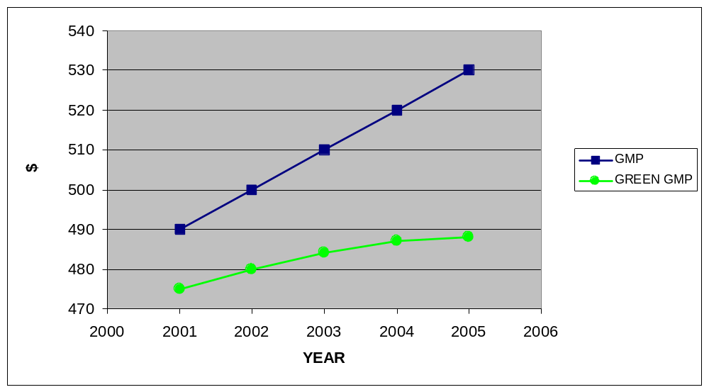Figure 1: Unplanned Development GMP Hypotheses
(in billions of U.S. Dollars)
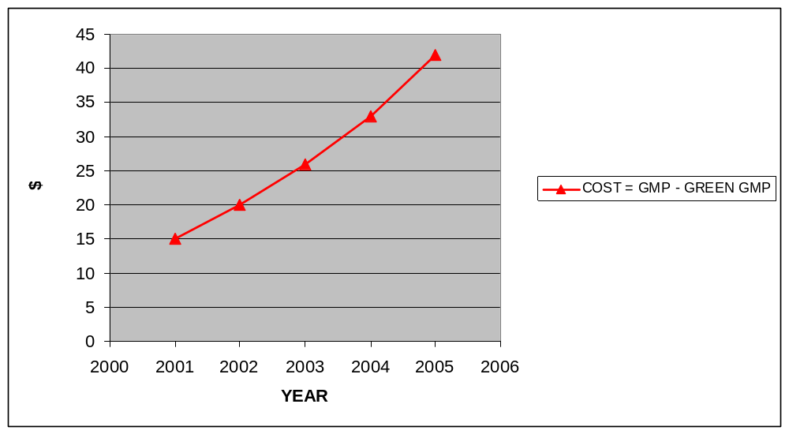Figure 2: Unplanned Development Cost Hypothesis
(in billions of U.S. Dollars)

Meanwhile, in a planned city the difference between GMP and Green GMP will remain stable. This stable cost will be less than the cost of development in an unplanned city because the environmental impacts of a planned city will be kept at a minimum.
The following two figures outline the hypotheses for a planned city:
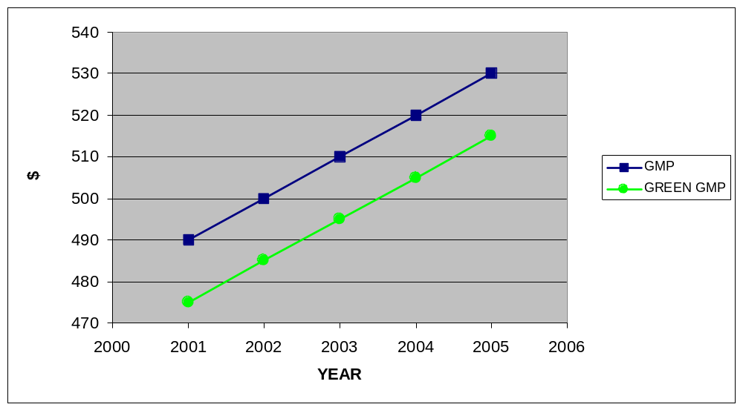Figure 3: Planned Development GMP Hypotheses
(in billions of U.S. Dollars)
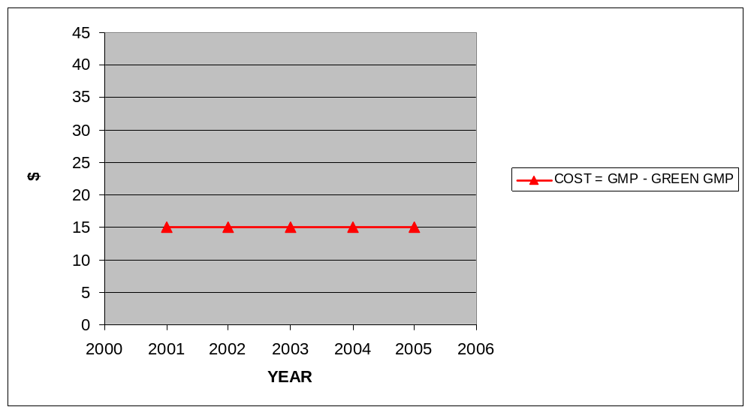Figure 4: Planned Development Cost Hypothesis
(in billions of U.S. Dollars)

Both qualitative and quantitative observations are used. The qualitative observations used are the cities’ respective histories and basic observations of the impacts of development on the environment. First, a narrative history of each city’s development is reviewed. Next, the effects of development on industry, water and energy, and transportation are analyzed. Finally, only after thoroughly describing the history of development, its effects, and the city’s current state, are the quantitative indicators introduced.
This methodological approach was chosen to refute the main argument made by the critics of planned development that claim planned development hurts the economy. Economic health is usually measured by GMP and critics claim that if GMP is rising then growth is occurring and the economy is healthy. This thesis concedes that GMP will continually rise in unplanned cities and by doing so comes to agreement with critics of planned development. Despite conceding this point, this thesis is able to corner critics through logic and by showing that the economic growth of unplanned development is partly due to false GMP gains through environmental damage. Even if the detractors do not agree with the method of determining Green GMP, they are forced to see some of the flaws in GMP data and learn about some of the effects of unplanned development on the environment. Eventually, the flawed logic used in advocating for unplanned development consisting of, “If there is growth, then the economy is in good shape,” will be proven false. The contrapositive, “If the economy is not in good shape, then there will not be growth,” will most likely never occur, showing one of the many flaws in their argument.
After seeing the history and effects of unplanned development in an area, it will be hard for an economist to just use GMP to measure the economy of an area, especially since GMP actually increases with polluting activities and again during clean-up, it is boosted by crime in that constituents pay to protect themselves through industry and taxes, GMP increases when humans deplete natural resources (e.g. oyster and crab industry in the Chesapeake Bay region and oyster and lobster industry on Long Island Sound), and GMP actually increases with sprawl because new businesses are created and government capital improvements bring water and energy out to the new communities created by sprawl.
Finally, even if detractors and economists discount the results, this paper contributes to a needed discussion about the problems with GDP (Gross Domestic Product – a national indicator of total goods and services produced) and the need to address those problems by redefining GDP and its municipal derivative GMP. By calculating the costs of development, this paper gives urban policy professionals another weapon to use in their battle to implement smart growth policies by selling smart growth to the American public - a public that always favors something that will save them money.

History of Urban Planning
Land use planning techniques have been practiced since humans first began to farm. In fact, just selecting the site of a farm, or preparing for a city’s defense, is planning. For example, Athens and Sparta grew outward in a sprawling fashion in order to acquire more arable land, just as Los Angeles sprawls today in order to acquire water and energy. One could argue that the city-states of Ancient Greece resemble the satellite cities of Chicago. If sprawl has been around for such a long time what exactly causes sprawl? There are many contributing factors and historian Robert Bruegmann argues that anti-urban attitudes, racism, economic factors, capitalism, government policy, technology, and affluence all play a role.
By the middle 1850s, industrialization was affecting urban life and “pollution, crime, immigration, noise, traffic, and poverty were increasingly seen as a threat to the good life.” Urban dwellers saw these threats as reasons to move away from the city, which led to sprawl.
The first anti-sprawl campaign occurred in Great Britain in the 1920s when Britain’s literary and artistic elite, who had long lived in the suburban countryside, became angry with their new neighbors. The second campaign occurred in the United States after World War II spearheaded by literature suggesting that sprawl was detrimental to the economy. Authors attempted to link pollution with sprawl and used statistical and economic models to argue that “planned communities were less expensive than unplanned communities and higher densities, more mixed-use, and more compact development would be less expensive than low-density sprawl.”
Since the 1970s, the anti-sprawl campaign has revisited the “costs of sprawl” argument, but detractors like Bruegmann argue that sprawl is actually cheaper:
However, this argument is a little like saying that it ought to be cheaper to renovate an old
building than construct a new one. Sometimes it is, but often it is not. In the case of cities, a little
closer examination reveals that much existing infrastructure, schools, for example, or the facilities
devoted to freshwater delivery, wastewater treatment, and transportation in the central city, were
never really adequate to begin with and today would require extensive improvements to bring
them up to current expectations. The costs of doing so, particularly in densely built-up cities, is
often considerably higher than it would be to start afresh in an outlying area. As a result, it may
make perfect sense to build relatively inexpensive and up-to-date new schools or roads for new
residents at the suburban edge, allowing the existing roads or schools in the central city to better
serve a reduced population until gentrification and rising land values make possible the very
expensive renovation of the old infrastructure.

There have been many attempts and different tactics at reducing sprawl or living with it. After World War II, many European cities used top-down planning to reconstruct their cities, in particular France, Great Britain, and the Scandinavian countries. London was rebuilt using a tactic calling for concentric rings in which open space was protected through the establishment of public parks and “the overspill from the city and any growth would be accommodated in discreet new towns based on garden city principles and scattered around the area outside the greenbelt. Some say this drove housing prices up because land became scarce and families were forced to live in high-density areas they otherwise would not have chosen to live in. Critics also argue that massive congestion problems began as the automobile was used to drive into the city rather than drive away from the city.
Meanwhile, in the United States top-down land use planning was met with resistance and viewed as undemocratic. However, some states have enacted statewide land use planning and zoning laws.
In many cases abroad, however, development rights are leased from the state and private participation in infrastructure (PPI) is not only allowed, but encouraged. PPI is common in East Asia, Latin America, and the Pacific. PPI , however, proves to play a limited role in improving urban services delivery and may work better in developed nations where government assurances can attract PPI.
As automobiles became affordable, more people moved away from the city. “Trucks and cars, which were mass-produced since the 1920s, freed industry from dependence on railroads and rivers, thus altering commuting patterns and the location of jobs…” In addition, the “hub-and-spokes” method of scheduling transportation in which more trains and buses run during morning and evening rush hour, as compared to the European model where train service is relatively uniform throughout the day, led to more Americans shifting towards the automobile where one can travel at anytime to any place.
After World War II, the housing boom led to an expansion of suburbs, department stores followed residents to the suburbs, and in 1956 the National Interstate and Defense Highway Act changed America’s landscape. The staple of suburban sprawl, the shopping mall was developed by an Austrian, Victor Gruen, and was supposed to “evoke a European city center.” Americans responded well to malls and they quickly became a part of American life.
Up until the 1970s, downtowns held the most important economic power of a region “the jobs, the office space, the economic activity,” but today there are numerous power centers within a city and downtown is not as powerful.” As a response to the suburbanization of America, city businesses began forming downtown business associations in order to promote central business districts to renew downtowns. These business development districts “need strong leadership and vision and usually succeed when organized into a nonprofit organization focused on a specific downtown district.”
Attempts at combating urban sprawl have been continuous in the United States. “Urban planning interventions seek to constrain the market’s sprawling tendencies through regulatory tools aimed at fostering development forms that the market is incapable of providing.” Some believe these interventions are warranted, while others feel that they are “unjustified impositions on households’ freedom of choice, with scarce evidence of benefit in reducing pollution or congestion.”
Another attempt at development regulation came in the form of required environment impact statements (EISs). EISs are costly and often slow down sprawling and smart growth development alike and cause projects to become so costly that they die.
Despite all of the attempts at regulating sprawl, it has become “the preferred settlement pattern everywhere in the world where there is a certain measure of affluence and where citizens have some choice in how they live… Sprawl at last became a mass phenomenon” in part because of one of the tools created to regulate it: zoning.
American land use planning came into being at the end of the nineteenth century as a result of “post-Civil War turmoil” in which a “social rationality” emerged in order to create order out of the “urban ills” attributed to industrialization. Zoning took power away from laissez-faire development.
Zoning was introduced to the United States in Los Angeles by an experiment in which residential areas were separated from industrial areas in 1904. By 1908 a city-wide zoning law went into effect. The zoning used in Los Angeles was single-use, meaning that an area was either zoned commercial, industrial, or residential. Single-use zoning became popular and many argued that single-use zoning was a major contributing factor to sprawl. Separation of industry and residential areas “remains as good an idea today as when late 19th Century reformed it to address unhealthful urban conditions” and is an example of strong land use regulatory power.
Since its inception, zoning’s effects have been discussed and some social science research suggests “zoning and other municipal interventions…lead both to development that is lower in density and to communities that are more exclusive than would arise in the absence of regulation.” More specifically, “the American way of zoning” separates land uses, specifies wide roadways, and mandates large parking areas.
Alternatives to single-use zoning are often discussed. In his book Zoned Out, Jonathan Levine describes the effects of using two alternative paradigms of metropolitan land use policy shown below:
 | PARADIGM 1 | PARADIGM 2
Explanation for scarcity of alternatives to sprawl | Market disinterest | Regulatory barriers that exacerbate market tendencies toward sprawl
Thrust of regulatory reform | Market-forcing regulations | Lowering of regulatory barriers to alternative development forms
Justification for regulatory reform | Scientific proof of benefit of alternative development forms | Expansion of household choice
Figure 5: Levine's Paradigms

In the first paradigm, alternatives to single-use zoning are only considered if they are proven scientifically, where the government wants to regulate land use, and the market is not interested in dealing with sprawl. Meanwhile, the second paradigm is characterized by an expansion of choice rather than behavior modification. “Empirical research on the impact of land-use regulation seems to point toward the second paradigm…seem to be market-enabling rather than market-forcing, since they lower the barrier to alternative development forms.” Levine argues that “municipal regulation that zones out the alternatives to sprawl is neither a preordained state of nature nor the free market’s invisible hand, but a governmental decision to constrain market processes.”
Zoning conflicts often occur between developers and neighbors because zoning is viewed as the government protecting private property rather than a regulation of an economic activity. Developers often want more density while residents often argue for less density, but a common belief is that regulation is geared toward constraining sprawl. Some argue that empirical evidence tends to find “municipal land-use regulation to be a binding constraint that lowers development densities and creates more exclusive communities than would arise under a free market” and zoning is in fact a free market restriction.
Zoning was meant to reduce sprawl and serve as the main form of urban planning, but it often encouraged sprawl through single-use zoning. In order to reduce some of the negative effects of “urban planning by zoning,” during the 1960s and 1970s, zoning regulations began to allow for “cluster development” in which areas were zoned for mixed-use and “a number of units could be clustered together, not only saving money on infrastructure and other costs but also leaving the remaining land as permanent open space.” In addition, planned unit developments (PUDs) became more popular to make zoning more flexible. In PUDs, planners and developers are given the right to negotiate the uses of the land on which they build on. Finally, another zoning trend developed that “mandate[d] large-lot requirements in rural areas.”
With zoning now the main tool of governments to regulate land use, how can one improve zoning practices in order limit sprawl? Or is limited sprawl even a good goal? “Can land-use regulatory policy actually raise development densities and land-use mixing to levels that the market is not interested in providing?” These are some of the questions at the heart of the urban policy debate today.
While zoning can accommodate for dense development, it cannot compel people to move into the city. However, restrictive zoning can in fact limit density. So less restrictive regulation, may be better than prescriptive zoning for smart growth.

Urban Planning Schools of Thought
There are many forms of urban planning and most can be divided into a few schools of thought with some cycling through popularity in a dialectic fashion.
During industrialization, the wealthy drove development through market-based planning without restrictions. Market-based planning has grown in popularity in recent years and has been endorsed by numerous politicians, mostly Republican, and cited in arguments in favor of congestion pricing, which is usually favored by economists and environmental groups. While Republicans and environmentalists are interesting bedfellows when it comes to market-based planning, further discussion of this union is another research paper unto itself.
Industrial Revolution market-based planning gave way to the concept of the garden city, in which commercial, industrial, and residential land were to be carefully regulated and growth constrained by a greenbelt, leading to healthier living. Many modern planners still frequently invoke the garden city concept today with different twists. The garden city concept is considered modernist.
The Chicago School borrowed many of the concepts of a garden city in that it segmented uses of the city (zoned) and stressed better aesthetics and “the betterment of commercial facilities; to methods of transportation for persons and for goods; to removing the obstacles which prevent or obstruct circulation; and to the increase of convenience.”
With the advent of the automobile, a new modernist school of thought emerged calling for building upwards, not outwards, and building highways into the city, called urbanism. Some argued that this leads to more sprawl, and by the 1970s many were clamoring for a “post” modernist way. Today, post-modernism is divided into two main camps: market-based planning (urbanism), which aims to limit government’s role in development, and New Urbanism, also known as smart growth, aims to regulate development and encourage pedestrian friendly, transportation-oriented communities. Market-based Urbanism and smart growth are overwhelmingly the most popular schools of thought today and are the focus of this thesis because both have proven that they can transform urban areas and reshape a city.
Market-based planning takes many forms and proponents say that “it is hard to imagine any form of urban intervention that exists or could exist outside of the market, that is to say outside of contemporary life. All urbanism are market urbanisms…” Lars Lerup, a Swedish immigrant and the Dean of Rice University’s School of Architecture, comments extensively on the “American Dream” and how it is based on the market, car-oriented, and space/distance seeking. However, Lerup refuses to discount the American way of development, currently dominated by market-based planning that takes advantage of large lot zoning. “If I have an argument with the so-called New Urbanists, it is that they are too ready to go back to the old city, and they don’t have enough faith in this new motorized city that tries to overcome distance – and tries to make distance at the same time.”
Market-based planning takes shape in many different forms with all forms relying heavily on the automobile as the mode of transit. The two main forms are strip development and leapfrog development. Strip development is best exemplified by office parks and shopping malls that provide ample parking and are usually only accessible by the automobile. Meanwhile, leapfrog development is also car centric and occurs when one area is developed and then a few miles away another is developed with a similar function with miles of road between the two developments.
New Urbanism “claims a finer mixing of land uses and socio-economic-racial groups in a physically coherent way can go a long way toward social and physical accessibility and ultimately toward sustainability.” Within the New Urbanist camp there are many variations and the movement “struggles between two identities, one a lofty set of principles that many criticize as utopian and the other a style which is stereotyped as retro and simplistic.” These principles include building neighborhoods that are walkable, do not rely on an automobile, have mass transit readily available, and are zoned at medium to high densities at the commercial and residential levels in the same area and sometimes same building. Another big tenet of smart growth is regional planning, in that one city should plan in tandem with another and the rest of the region in order to optimize quality of life, transportation functionality, open space, and minimize environmental damage.
Smart growth’s basic form at the regional level is outlined below:
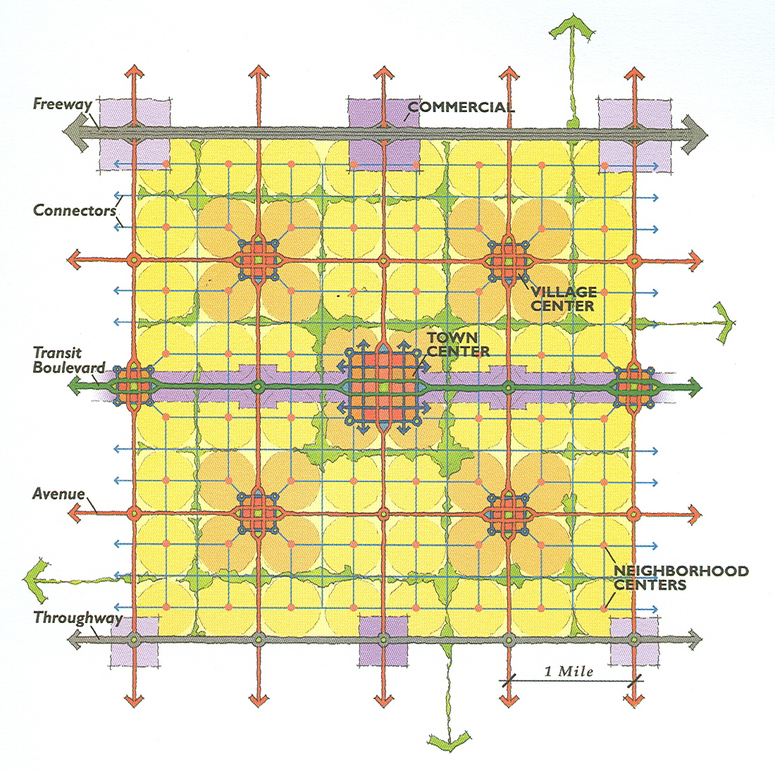
Figure 6: Image of an Urban Network
Smart growth advocates infill development in order to create a lively city center and save on the infrastructure costs of extending water, power, and other public services to new developments. Brownfield redevelopments, in which environmentally damaged (e.g. Superfund sites) and downtrodden areas of the city are built back up in order to create a lively city center, improve municipal economic output and also save money on capital improvement infrastructure extensions. Finally, smart growth advocates mixed-used and compact developments which usually go hand in hand. Mixed-used development means that areas are zoned for more than one purpose cutting down on large-lot zoning that increases sprawl. By zoning for mixed-used, compact development is encouraged. This results in less sprawl, more open space, and more money in the city’s treasury.
Another school of thought is called Everyday Urbanism. Everyday Urbanism hopes to “domesticate urban space, making it more familiar, more like home,” but is a niche school of thought based on a literature review. The main advocate, Margaret Crawford a professor of Urban Design and Planning Theory at Harvard University, cites Los Angelenos selling rugs on residential streets amidst vendors as a form of Everyday Urbanism, because it is unplanned and varies in time and form. Everyday Urbanism is “non-utopian, informal, and non-structuralist… [its] openness to populist informality makes [it] informal and conversational, as opposed to civic and inspirational.”
Another niche school is the Post Urbanist camp that welcomes “disconnected, hyper-modern buildings and shopping-mall urbanism.” Some may view this as an offshoot of market-based planning because it fantasizes about “new forms of knowledge, new hybrid possibilities, new unpredictable forms of freedom” in architecture.
Finally, the L.A. School emerged in the middle 1980s dedicated to exploring the growth of Los Angeles in a global context. The L.A. School believes that every type of urban planning is evidenced in Los Angeles and Los Angeles can therefore serve as a growth model for the entire world since market-based planning and New Urbanism peacefully co-exist.
L.A. embodies how the late twentieth-century urban landscape has been radically altered by a multifaceted global-restructuring process – the ‘hollowing out’ and redevelopment of downtown, the abandonment of the inner city and minorities, the decay of older suburbs, the decentralization of industry, the emergence of information-age ‘edge cities,’ and the hypermobility of the international capital and labor flows.

II. NEW YORK, NEW YORK: INDUSTRY
The New York region, as defined by the Regional Plan Association, “has a population of 20 million and sprawls across parts of three states...” and it accounts for “10 percent of the nation’s gross domestic product.” This chapter will deal primarily with industry loss on Long Island, one of the major geographic suburbs of New York City. Long Island is the largest island adjoining the continental United States extending approximately 118 miles east-northeast from the mouth of the Hudson River, encompassing four counties: Kings (Brooklyn), Queens, Nassau, and Suffolk Counties. With 1,180 miles of shoreline, all counties, especially the two eastern most, Nassau and Suffolk, attract tourism. With a population of 2.86 million, the Nassau and Suffolk Counties combined have a larger population than 19 other states.
In this chapter, the history of Long Island’s development is documented, sprawl’s effects on industry, water, power, and transportation are discussed, GMP and Green GMP calculations are compared, and recommendations for future development are made. It is clear that the industrial economy of the area is linked to its environment. A total ecosystem collapse of the Long Island Sound would bring serious economic problems (e.g. loss of the lobster industry, loss of the wine industry, loss of tourism) to the area.

History of Development
The Dutch first settled New York City and Long Island. By 1635, English settlers, particularly Quakers, had started settlements across the island. Farms and small trading posts sprung up and the area was mostly rural for a few more centuries, with little to no environmental damage. The Long Island Sound was inhabited by whales and also provided a steady fish supplement to the mostly agricultural diet of the settlers. The horse was the primary means of travel for the area.
By 1807, steamboats began to shuttle city residents to Long Island, and the rich began to view Long Island as a viable place to build homes because of the two dominant forms of transportation. Throughout the 1800s, the steamboat tied the North Shore communities together with New York City and the population of Long Island rose, concentrated on the North Shore where transportation by steamboat was available.
The railroad became a viable transportation option for city residents wanting to escape to the country in 1844. The Long Island Railroad (LIRR) was completed with a line to Greenport, a north fork town on the Sound, and allowed more people to settle the towns located along the rail line. With the advent of the train, the serenity and environmental bliss that settlers and the Native Americans enjoyed began to change because now people were able to settle in areas where transportation by boat, and now train, was available.
During the middle 1800s to early 1900s, Long Island was a playground for the rich in some areas, a fisherman’s paradise in others, and a rich farmland in the east. On the North Shore in Nassau County, Gilded Age mansions were the norm, and the Glen Cove area began to be known as Long Island’s Gold Coast, because of the numerous estates that sprung up. Soon Henry Ford developed the Model-T, and things began to change even more.
At first the automobile was a toy of the rich, but during the prosperous period of the 1920s, its price was lowered allowing more people to afford it. After World War I, the car became “one of the mainstays of transportation for the average citizen, and much of its glamour disappeared. As use of the auto became more widespread, a huge clamor arose everywhere for the improvement of existing roads and the construction of new ones.” Automobile ownership became an essential part of middle class living and registrations rose by more than 150 percent between 1920 and 1930. In addition, the population of Nassau County tripled.
The new drivers/residents of Long Island were “adamant about using something more substantial than Hudson River gravel as a base for the roads;” they did not just want more roads, they wanted quality, or asphalt, roads. “The American dream was about to be redefined to include a one-story house with a backyard, a next-door neighbor, and a garage to shelter the family car.”
More people began to move to Long Island from New York City in the 1920s. “Between 1922 and 1929, nearly 900,000 houses were built each year in the United States, a rate twice as great as the previous seven years.” After the stock market crash of 1929, the Great Gatsby mansions became “real estate to be grabbed up, subdivided, developed, and sold to people made newly mobile by the auto.” In 1920, Nassau County had 126,000 residents and Suffolk 110,000, both with significant tourist populations and part-time residents.
After World War II, Long Island experienced a period of rapid suburbanization centered in Nassau County. This suburbanization was fueled by the government, media, and by the veterans’ quest for the American dream returning from the war. It was also made possible, primarily by two powerful men: William J. Levitt, general manager of the Manhasset construction firm Levitt and Sons, and Robert Moses, who served at different times as the Long Island Parks Commissioner and the Triborough Bridge Authority Chairman.
A great example of the type of development of the period is the development of Levittown and the transformation of nearby Roosevelt Field from an airfield to a major shopping and industrial center.
Levittown is interesting in many ways because it assumed a national identity as “the quintessential postwar American suburb.” It was Long Island’s introduction to the post-war housing boom. This boom was made possible because of the National Housing Act of 1934, which encouraged the production of low-cost housing. Developed for the depression, but taken advantage of by developers, the act allowed Levitt to take vacant, underutilized land, and sometimes farmland, and turn it into instant communities for the returning war veterans, providing a ready supply of homes, and a solution to the possible housing crisis. This act was further enhanced by the Veterans Emergency Housing Program (VEHP) of 1946, which encouraged prefabricated homes and offered monetary guarantees to those who would venture into the field, and also by cooperation between the Federal Housing Administration (FHA) and the Department of Veterans Affairs (VA) with the financial industry. These acts served as the national government’s stamp of approval toward the type of development Levitt created and capitalized on.
Levittown initiated a new kind of instant community on Long Island. It followed the national government’s guidance, which encouraged the production of large-scale suburban housing projects. This enabled thousands of the lower-middle class veterans of World War II to buy homes using underwritten/guaranteed mortgages – a practice still in effect today for veterans. Through its policies, the federal government allowed more people to achieve the American dream – a private house and lot. “Levittown was the reduction of the American Dream to a practical and affordable reality, made possible in large part by the cooperative efforts of the government, the builders, and the banks.”
This American dream was popularized by the national media, which paid tribute to the suburban setting from school books to magazines to television, and painted a picture of a commuting father and car-driving wife and mother in short stories and numerous magazines. Television and radio families also idealized the private home consisting of a nuclear family living in their very own Cape Cod.
With the national government and national media/entertainment industry already supporting development, Levitt gained the support of the important local power brokers. Local labor unions were not happy with Levitt’s plans because the projects were seen as bringing undesirable, poorer people to the community and also taking away specialty trade union jobs by using assembly line house production methods. Levitt was able to quell this discontent by contracting with the local unions ensuring jobs would not be lost, thereby ensuring that they would not oppose any of his projects.
Levitt gained popular support by launching a very effective public relations campaign complete with information handouts on his “garden communities” and sold the area’s fledgling newspaper, Newsday, on his projects which would publish supportive editorials. With the local labor unions, local media, and most of the local residents on board, Levitt was able to sell the returning war veteran on his type of housing. Levittown quickly grew to a town of 82,000, the largest private housing development in history. The success of Levittown, and the pattern it established, changed the landscape of Long Island, and America, forever.
With new housing projects sprouting up on farmland and the vacated potato and cornfields of Long Island, roads needed to be built. Robert Moses, formerly the Long Island Parks Commissioner and Chairman of the Triborough Bridge Authority, obtained millions of federal dollars released to build highways in New York, claiming that he was working for the people’s right to mobility. In reality, however, suburbanization led to the abandonment of the inner city. Moses’ affinity towards the highway over public transportation shaped New York City and its suburbs into the sprawling metropolis it is today.
Moses had been developing a road network for New York City and its surrounding areas since the 1930s, consolidating power over New York area transportation by building roads with New Deal money. Long Island grew extremely fast because of the new highways and expressways built in the period after World War II, with the federal government’s approval. The New England Thruway, Hutchinson River Parkway, Northern State Parkway, and the Long Island Expressway (LIE) all were Moses’ projects.
Moses continually built more and more highways during his tenure. He also did not disapprove of any new housing developments, like Levittown, and “in the area of planning and development on Long Island, Moses’ lack of opposition was tantamount to approval.”
Moses continued to build more roads to cut traffic just as he did in the 1930s where he would “open the Triborough Bridge to ease the congestion on the Queensborough Bridge, open the Bronx-Whitestone Bridge to ease the congestion on the Triborough Bridge, and then watching traffic counts on all three bridges mount until all three were as congested as one had been before.”
Moses was also empowered by the lack of safe public transportation in the area. In the 19th Century, steamboats and railroads were safe popular transportation options for Long Island, but by the 20th Century, the steamboat was close to obsolete, and the railroad was not very popular due to unsafe conditions and the residents’ automobile preference. Conditions on the LIRR helped many suburbanites make the decision between car and train even easier. LIRR deficits grew due to competition from cars and buses, so budget cuts led to decrepit train conditions, less workers, and two train accidents in 1950 and 1951 that left 100 dead. The collective decision was made and Long Islanders overwhelmingly became even more vehicle dependent.
From 1945-1970 development centered around Nassau County, following the already established pattern of building housing developments and more roads. By 1970, Nassau’s population had grown to 1.5 million and Suffolk’s to 1 million. But with the completion of the LIE to Riverhead in 1972, and New Yorkers affinity and preference to toward the car, Suffolk County was opened even further to suburban home seekers. This continued the trend that began after World War II of building roads and communities, whereby the highway system encouraged low density settlement and suburbanization.
The bi-county Nassau-Suffolk Regional Planning Board called for the construction of 128,500 apartments in its Comprehensive Development Plan to house some of the anticipated 2.3 million residents of Nassau and Suffolk counties in 1985. The plan also included multi-family housing to meet the onslaught of new residents and ensured the new developments were built in clusters to minimize the effects on the environment and leaving wide areas of open space.
With cluster development, or scattered or leapfrog development, “residents and service providers must pass vacant land on their way from one developed use to another.” Cluster development became the main form of development on Long Island until maximum capacity was reached because the majority of residents had large lawns and “personal space.”
At this time, the open spaces promised by the regional planning board were developed in class strip sprawl. Currently, cluster development’s open spaces are being developed in a classic strip development fashion in which “the consumer must pass other commercial uses (usually on crowded arterials) on the way from one store to the next: the antithesis of one-stop shopping.” The result is unorganized, in cohesive development whereby the open spaces promised by cluster development are engulfed by strip sprawl on the arterials leading from one “environmentally friendly” cluster to another.
There are many problems associated with this current form of development. According to Ewing, “Strip development presents a solid wall of commercial uses. Low density suburban development sub-divides land until every developable acre is spoken for; although, if you count people’s yards, there is abundant open space, it is all in private hands or in holdings too small for community uses. The ultimate caricature of this situation is the walled and gated sub-division, where no land at all (not even street rights-of-way) is public.”
With the other form of sprawl, cluster development, already in place, strip development is now eating away at any open space left, forming what seems to be a jumbled mess of strip malls along major arterials with the old clusters behind it.
With these types of development choking Long Island, it was also hard to re-orient residents back to the LIRR. With big department stores following residents to the suburbs, as Gordon and Richardson argue, residents had no reason to travel all the way into New York City to shop, they could just drive to the local mall that has ample parking for their cars. In addition, as Gordon and Richardson argue, corporate headquarters followed the new residents to the suburbs, cutting down on New York City bound commuters. Numerous plants and corporate headquarters relocated along the LIE and also along Route 25, which runs along the North Shore of Long Island and is still the only route to the north fork’s end – Orient Point.

Effects on Industry
The economy of Long Island is heavily influenced by the health of its abundant water, both on the North Shore (lobster, wine, tourism) and the South Shores (tourism). Long Island’s development has had a major effect on the fishing industry, and will most likely damage the tourism and wine industries as well.
Long Island’s industry has mainly been affected by development patterns that favor the use of the car, cluster development, and strip development. All eliminate open space and permeable surfaces in favor of asphalt that funnels runoff into the Long Island Sound, which is the main driver behind the fishing, tourism, and wine industries.
Dumping of nitrogen products into the Long Island Sound negatively affects industry. First, horse manure was dumped into the East River, which empties into the Sound, and dumped directly into the Sound, starting a trend of dumping into the Sound that continues today. In addition, in the past, New York City dumped untreated sewage into the Long Island Sound.
The train brought more and more people to Long Island, and the residents used the same waste management methods of the 1600s, dumping into the Sound, further increasing the levels of nitrogen in the Sound.
Just as the horse gave way to the train, the train gave way to the car, and with it, the car brought miles of improved, impermeable, asphalt surfaces (to the residents’ applause) leading to an increase in storm-water runoff containing toxins (such as lawn fertilizer, oil, etc.) into the Sound.
The Long Island Sound, once called the “American Mediterranean” by Daniel Webster, is on the brink of disaster primarily due to sprawl. In the 19th Century, virtually every town and harbor on the Sound supported an oyster industry. Oyster fisherman would catch oysters and immediately send them to New York City keeping the fish markets full. In 1892, some students at Wesleyan University in Middletown, Connecticut, began to get sick with typhoid fever due to consuming Long Island Sound oysters that had been feeding off sewage. A negative connotation towards Long Island Sound oysters stuck for some time nationwide due to this incident. This, combined with over-harvesting and a rash of bad hurricanes in the late 1930s, led to a complete collapse of the oyster industry, and today only the few still in the business know that it is not extinct. In addition, the low oxygen levels in the Western Long Island Sound, where the oyster industry was centered do not even support marine life today due to high nitrogen levels from sewage and runoff. If leaders had acted at the time to stop further contamination, and used the destruction of the oyster, once so easily obtainable from the Sound that Dutch settlers and Native Americans could survive on the shellfish alone, the problems that exist today might not have blossomed.
Direct dumping of sewage into the Sound is not the only factor that causes harm.
Houses built through large-lot zoning, which is the predominant form of development in Nassau and Suffolk Counties, can pollute on a similar scale due to runoff. Communities pollute the area’s water through the upkeep of the American dream – which includes a large lawn that requires fertilizer. “Chemical nitrogen fertilizers have been on the market only since World War II… each acre of fertilized lawn is covered with an average of 134 pounds of nitrogen a year.” Fertilizer washes out onto the streets, into the sewers, and into the Sound. In sum, 8,800 tons of nitrogen is added to the Sound through sewage dumping and runoff from improved surfaces.
The residents’ affinity towards the automobile also hurts the environment through runoff and acid rain.
But the growth of the automobile as the dominant form of transportation, and the spread of the suburbs more than doubled the amount of nitrogen that reached the Sound – by adding nitrogen directly, through sewage, and by impairing the land’s ability to absorb nitrogen. Development attacks the landscape’s autoimmune defense against pollution. Builders cover the land with impermeable structures, driveways, sidewalks, and roads; development compacts soils, wiping out their natural sponginess. When rain falls on an acre of woods, it percolates through the trees, shrubs, and soil, which sifts out organic matter and nutrients as the water seeps into brooks and streams. But if that acre is cleared for development, the forest’s ability to filter is obliterated, and the denuded land will release a thousand as many particles into the waterway as forested land would… In sum, when you increase impervious surfaces you increase the chance of nitrogen reaching coastal waters.

With the large amount of nitrogen flowing into the Sound, an irreversible environmental catastrophe is waiting to happen and has already happened in some areas. This catastrophe is primarily caused by Long Island’s development… development that led to increases in nitrogen in the Sound and could completely destroy the fishing and tourism industries.
“As long as the amount of nitrogen flowing into the Sound was relatively low, the mass of plankton remained under control and oxygen levels stayed high enough to sustain the winter flounder, blackfish, and lobsters that crowded into the Sound.” In 1972, the Sound’s central basin was the site of what scientists called a “benthic crash” –a large-scale killing of bottom-dwelling animals. Dissolved oxygen levels remained very low in the Western Long Island Sound, as low as 1.3 milligrams per liter in some parts. However, if there were only a benthic crash, the common resident would not know anything about what was going on. Only scientists who monitor a body of water would know anything. This is what happened on Long Island, so residents’ behavior was not modified, and nitrogen was continually dumped into the Sound, just as it was in 1892, sapping oxygen from the Sound.
Hearing about a possible catastrophe waiting to happen in the Sound, and having finished with a shocking Chesapeake Bay study the year before, the Environmental Protection Agency (EPA) obtained approval to study other estuaries to include the Long Island Sound in 1985. The main problem that was to be researched was to see if dissolved oxygen might be sinking to unhealthy concentrations.
Oxygen levels were very low, but the Sound seemed healthy. Then suddenly in the summer of 1987, “vast blooms of algae had turned the Sound an opaque reddish-brown, oxygen levels were pushing down toward zero, toxic hydrogen sulfide was being loosed from the sediments, and fish and lobsters were dying in uncounted numbers;” the algae and plankton were multiplying because of a readily available food source (waste) and were consuming all of the available oxygen for themselves.
Lobstermen began pulling up hundreds of pounds of dead lobsters in the Western Sound. Meanwhile on the eastern edge of the dead lobster catches, lobstermen were pulling up enormous catches of lobsters because the lobsters had fled from oxygen-depleted areas into oxygen rich pockets (called herding) where fisherman had the chance to hone in on them. This “bliss before disaster” fooled lobstermen into thinking that nothing was wrong with the Sound in their area. This condition is called general hypoxia, in which oxygen levels range from one and a half to three milligrams per liter. The hypothesized culprit was the breakdown and sewage spills at a sewage treatment plant in Hempstead Harbor and then smaller spills in Larchmont and Mamaroneck. This could have been the event that pushed the Western Long Island Sound over the edge.
In 1988, fishing went on as usual, the Sound seemingly recovered, but then in 1989 hypoxia gripped the Sound from New York City to as far east as Shoreham (60 miles east). Hypoxia was spreading eastward. But fisherman again caught fish and lobster in the central Sound where it is deeper and further east where herding occurred yet again.
These conditions continue today with each year the Sound being on the brink of disaster. The lobster industry has suffered tremendously. Although 1987 and 1989 were bad years for lobster fisherman, 1998 and 1999 turned out to be worse, but for a different reason:
Since Fall 1999…lobsters have been experiencing unprecedented outbreaks of disease that have resulted in massive mortalities, particularly in the Sound's western basin. At the same time, lobsters in the eastern Sound have been suffering from ‘shell disease,’ a bacterial infection that has been around for awhile but appears to have greatly increased.

In 1997, between 8.2 million and 10 million pounds of lobsters were harvested. By 2003, this was down to 950,000. “Lobsters are the most economically important marine species harvested in New York” and accounted for $29 million dockside in 1998 before the epidemic. The lobster catch was greater than the value of all finfish combined in 1996, 1997, and 1998, in New York State, according to National Marine Fisheries Service.
Many suggest that even though lobsters died off in record numbers due to hypoxia previously, the current lobster shell problem is a result of different kinds of environmental problems: global warming and pollution. Lobsters like water colder than 68 degrees Fahrenheit, a temperature the Long Island Sound often surpasses today, and high temperatures are known to contribute to shell rot. These temperatures and the high levels of PCBs and heavy metals found in the Sound due to runoff combine to form a potent cocktail often leading to lobster death.
The pollution of area waterways affects two industries greatly – the fishing industry and also the tourism industry, which is Suffolk County’s number two employer.
Each year the Long Island tourism industry earns $5 billion. In Nassau County, Jones Beach and Fire Island are always crowded to capacity and also attract numerous music concerts each summer. The Hamptons, located on the South Fork, bring millions of dollars to the area every summer, as New York City residents catch a Hampton Jitney bus, the LIRR, or drive to the Hamptons for a relaxing weekend on the beach. Bars, country clubs, designer boutiques, beaches, and nightclubs all draw New York City residents, as well as Long Islanders to the area. In addition to the Hamptons, a wine industry has excelled on the North Fork of Long Island where many take guided tours of the facilities and attend wine tastings on the weekend. Then in the center of Long Island, Riverhead’s Tanger Outlet Stores and the Splish Splash water park draw additional visitors.
However, traffic kills this experience, especially during summer weekends, because the parkways end before the main tourist destinations are reached transforming the country roads into a parking lot. Mass transit options like the Hampton Jitney bus or the LIRR can alleviate this problem.
Polluted water would kill the Hamptons experience and the established wine industry. Storm water runoff harms both the Sound on the North Shore, and the Atlantic on the South Shore, albeit not as much because it is an ocean. If development continued to encroach on the Hamptons, traffic would get even worse, and the appeal of a Hamptons getaway would lessen to New York City residents. All in all, development in the area must be constrained in order to prevent the loss of a $5 billion a year industry.

Effects on Water and Energy
Both federal and local governments encouraged Long Island’s growth and development. With this growth came an increase in demand for water and energy. Long Island has major sewage treatment and energy issues that need to be dealt with, all as a result of their development pattern.
On the waterfront, as already partially discussed, development has put an unbearable strain on existing sewage treatment plants. Long Island must take sewage treatment more seriously, especially since hypoxia has already struck. Any plan to ease the burden of nitrogen finding its way to the Sound must begin with treatment plant improvements beyond the Clean Water Act of 1972’s standard met by the activated sludge method that consists of treating sewage twice and removing 80 percent of nitrogen out of the sewage. In order to mitigate the risks of the other 20 percent of nitrogen, Long Island must adopt a process, called de-nitrification. This process has met resistance on Long Island because it would require more sewage treatment plants to be built, at a price of approximately $6 billion, and requires two additional steps beyond the current secondary treatment. A plant must run below capacity because initially treated sewage called sludge, must be kept for 8 to 15 days so bacteria can denitrify the sludge. The problem local politicians saw was that when the bacteria works its magic on the sludge, the nitrogen gas released creates a bad odor. One way to mitigate this not-in-my-backyard problem (NIMBY) is to change zoning laws of the area keeping treatment plants in industrial zones as far away as possible from the tourist and fishing zones important to the area’s economy.
Decades of growth in the 20th Century further added to the sewage treatment problem of the area, tripling the sewage flow into the Sound from the area’s treatment plants from 1945-1970. Nitrogen levels increased in the Sound due to all of the sewage dumping. “Nothing disrupts the Sound’s ecosystem like sewage. Every day of every year, eighty-six sewage treatment plants empty 1.047 billion gallons of sewage into the Sound and its tributaries… Their flow, if combined would make them the Sound’s fourth largest tributary.” This accounts for 29,600 tons of nitrogen, added to the Sound.
Long Island’s thirst for energy is a major concern that needs to be dealt with as it continues to develop. Having already rejected nuclear power in the 1980s when a state-of-the-art multibillion-dollar nuclear power plant was ready to become operational in Shoreham, residents do not have many choices in order to meet their exorbitant power needs. Long Island Power Authority (LIPA) proposed running an underwater wire to Connecticut under the Long Island Sound to add more power to the grid and lower electricity prices, and now residents are debating the project.
In addition, a liquefied natural gas station has been proposed in the central Sound in order to easily deliver natural gas to New England and the New York area. This project, known as Broadwater, is also under intense debate. Recently, however, New York State deemed the project as too risky and denied its permit because the project would damage the Sound’s ecosystem, the project is using public land for private gain, and the Sound is not an industrial park and Broadwater would set a bad precedent. The only way this project could still occur is if New York State reverses its judgment or the U.S. Secretary of Commerce rules that national energy priorities should overrule New York coastal management and then New York State bows to that pressure.
Finally, smoke stacks and oil-fired power plants are still in use on Long Island and contribute to the acid rain experienced in the area. This acid rain ends up injecting an additional 3,400 tons of nitrogen directly into the Long Island Sound, 46,000 tons landing somewhere on the Sound’s drainage basin of which 8,700 tons found its way into the sound through runoff. In sum, more than 12,000 tons of nitrogen pollutes the Sound through acid rain.
Basically, Long Island has power troubles, and needs more power, but the debate is ongoing as to how to meet these needs. Continued use of solar power, and the possible creation of wind farms off the Atlantic Coast are good choices for an area that needs to save itself from nuclear obliteration, further destroying Long Island Sound habitat’s by running electricity through the Sound, and moving on from Industrial Revolution age power sources. These clean options also prevent further air pollution, allowing for beautiful sunsets to be seen from Hamptons’ beaches all summer long.

Effects on Transportation
Long Island’s growth and its development affected transportation in a negative way – orienting residents towards the car and away from public transportation, which then led to more damage of the Long Island Sound and industry. Today, Long Island is suffering environmentally and aesthetically because of the transportation policies adopted and the manner in which it grew. In addition, the commute times for residents and the businesses and workers that depend on tourism for a salary are also being affected in a negative manner. This affects both workers that are commuting to New York City, and workers commuting to other towns on Long Island where industry and business have followed development to provide jobs.
As the horse gave way to the train and the train to the car, more and more people populated Long Island. A transportation policy focusing on the automobile led to impermeable roads and more storm water runoff into the Sound, affecting industry. On the national level, the Eisenhower administration approved of the recommendations brought forth by Lucius D. Clay, director of General Motors, to build many roads quickly and meet the nation’s transportation needs through the use of cars and trucks in 1954. Car ownership spiked nationwide and on Long Island. Meanwhile on the local level, Moses kept building roads and highways, but the highways and roads ended up generating traffic.
Planners could hardly avoid the conclusion that ‘traffic generation’ was no longer a theory but a proven fact: the more highways were built to alleviate congestion, the more automobiles would pour onto them and… force the building of more highways – which would generate more traffic and become congested in their turn in an inexorably widening spiral that contained the most awesome implications for the future of New York and of all urban areas… Pour public investment into the improvement of highways while doing nothing to improve mass transit lines, and there could be only one outcome… Moses’ immense new highways construction proposal… could only make congestion, already intolerable, progressively worse. His program… was doomed to failure before it began.

As the automobile gained popularity, modal split, or the percentage split between different commuter travel methods (e.g. train, bicycle, car, walking), swayed to the automobile (percentage of automobile use grew). Train safety issues also contributed to the shift and residents saw public transportation as unsafe and unreliable after years of neglect. Many commuters decided to just drive to work, rather than take the LIRR to work and then the subway to their city office. Bad conditions of public transportation in the greater New York area increases vehicle miles traveled (VMT) and leads to more runoff and more environmental problems, affecting the resources (e.g. air/water/noise) that are vital to continuing a great tourism industry, fishing industry, and wine industry. Ridership climbed back up after the Metropolitan Transit Authority (MTA) spent $40 billion in current dollar terms to refurbish it.
Cluster development led to more impermeable surfaces and encouraged the use of the automobile. It built up impervious surfaces for parking lots in every mall. The large parking lots associated with the new strip malls on Long Island are devastating to the environment. For each one acre of meadow, or previously permeable surface, that is paved over for a parking lot, there is 16 times more runoff.
The one saving grace of cluster development, open space, is now coming under attack by commercial strip development leading to a heightened dependence on the automobile and adding even more impermeable surfaces, creating even more runoff.

GMP v. Green GMP
New York City’s GMP has grown from $898 billion in 2001 to $973 billion in 2005. Green GMP calculations based upon subtracting infrastructure spending, water and energy spending, environmental protection spending, and loss of shellfish revenue, from GMP, also rose. However, the difference between GMP and Green GMP has been growing meaning that millions of dollars are being spent primarily because of a lack of planning. The calculated cost of unplanned development has risen from approximately 28 million in 2001 to 35 million in 2005. Unplanned development is risking to further harm the Sound. The North Shore towns abutting it “reap at least $6 billion a year in economic gain from industries whose well being depend on a clean Sound.” The GMP cost calculated does not take into effect this, or the historical loss of the oyster industry and probable future loss of the entire shellfish industry in the Long Island Sound.
Infrastructure spending numbers were gathered from the first part of the comptroller’s review of the mayor’s executive budget for New York City each fiscal year; environmental protection numbers gathered from part two of the comptroller’s reports; energy and water numbers were gathered from part three of the comptroller’s reports; and loss of shellfish revenue data was collected from the annual landing reports from the National Oceanic and Atmospheric Administration by adding the value of shellfish landings (e.g. lobsters, oysters, and clams) caught by New York and Connecticut, who both share the Long Island Sound and contribute to the GMP of the New York City metropolitan area.
New York’s unplanned development costs an average of $32.4 million per year, which is zero percent of the almost trillion dollar per year GMP. In support of the hypothesis, New York’s GMP and Green GMP did display a positive correlated relationship. However, both GMP and Green GMP were virtually the same minimizing the cost of unplanned development. Also, in support of the hypothesis that unplanned development’s costs will increase over time, the cost grew from $28 million to $35 million over five years. The null hypothesis was also rejected.
Despite all hypotheses being supported, unplanned development’s costs were relatively low. However, as shown earlier, the Long Island Sound’s health, open space, and traffic were affected greatly by this form of development. Another factor contributing to the relative low cost is the focus on the Long Island area. Industry loss in Westchester, Northern New Jersey, and Western Connecticut were not taken into account. In addition, despite New York seeming to have a relatively stable, low cost of development now, the calculations do not take into account the possible $6 billion in industry loss that will shock Long Island if the Sound becomes a dead body of water. New York’s Green GMP is not as stable as it seems, therefore its cost of unplanned development is not as stable as it seems either.
Below is a table, measured in thousands of U.S. Dollars, encompassing the findings from 2001-2005:
YEAR | GMP | INFRASTRUCTURE | WATER  & ENERGY | ENVIRONMENT | GREEN GMP | COST  OF  DEVELOPMENT | SHELLFISH  INDUSTRY
2001 | 898039000 | 24497 | 1823 | 2058 | 898010622 | 28378 | 186.8
2002 | 891657000 | 26659 | 1841 | 2205 | 891626295 | 30705 | 175.6
2003 | 911228000 | 28895 | 1847 | 2055 | 911195203 | 32797 | 184.0
2004 | 946355000 | 29959 | 2158 | 2453 | 946320430 | 34570 | 114.0
2005 | 973521000 | 30683 | 2460 | 2375 | 973485482 | 35518 | 105.6
Table 1: Data and Calculations for New York

Below is a graph of New York City’s GMP:
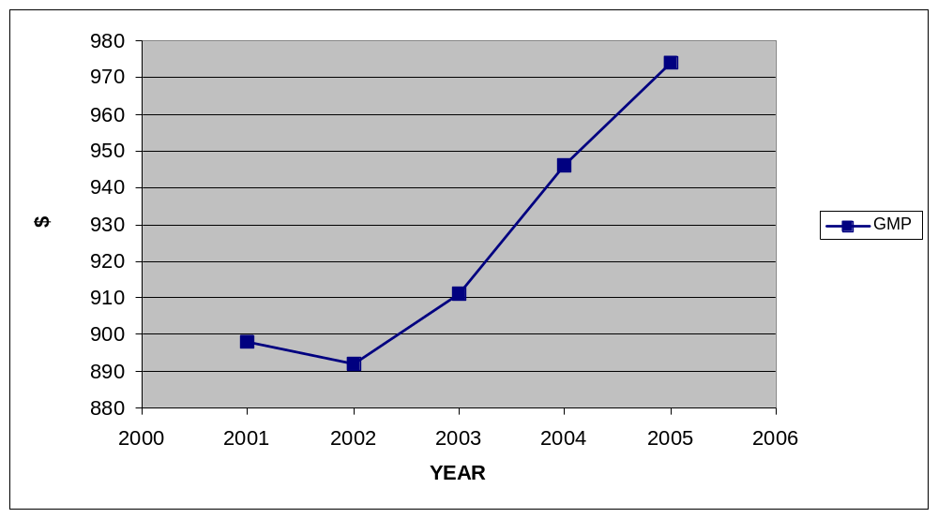Figure 7: New York's GMP
(in billions of U.S. Dollars)

Below is a graph of New York City’s Green GMP:
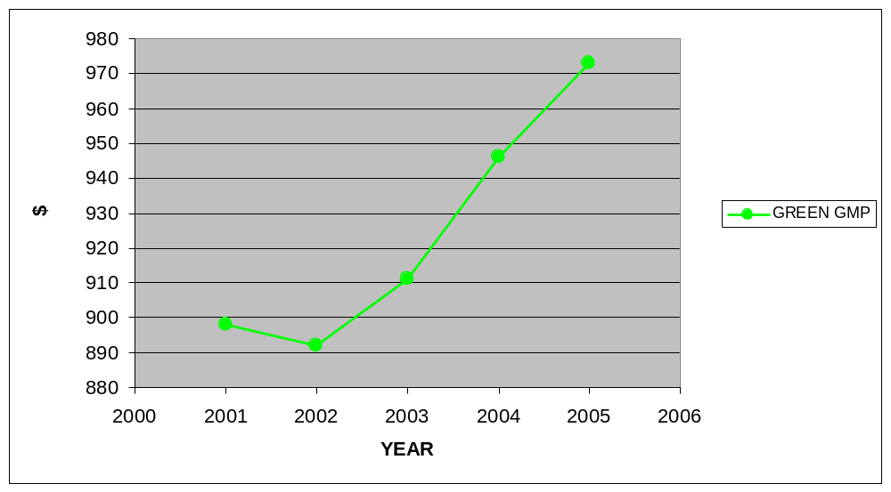Figure 8: New York's Green GMP
(in billions of U.S. Dollars)

Below is a graph of the cost of unplanned development (Cost = GMP – Green GMP):
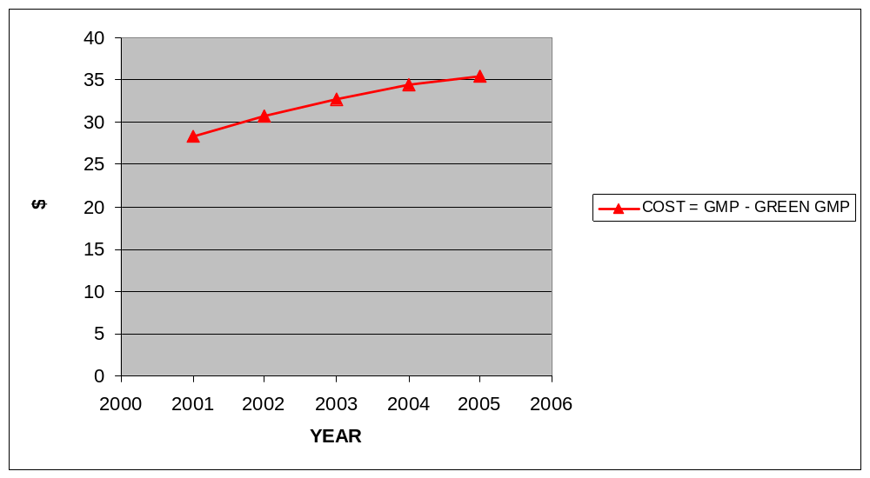Figure 9: New York's Cost of Development
(in millions of U.S. Dollars)

Recommendations
Auto dependency, cluster and strip development, and an increase in impermeable surfaces negatively affect the environment and economy of Long Island and the New York metropolitan region. In order for Long Island to continue to be an economically prosperous area, measures must be taken to guarantee its environmental well being for the long-term.
Long Islanders, like most Americans, love their cars. However, as stated earlier, driving is a large contributor to storm water runoff that pollutes Long Island’s critical bodies of water, most notably the Long Island Sound.
Ninety-four percent of Long Island households have at least one car; two-thirds have two or more. From 1980 to 2000, the number of motor vehicles grew by 19 percent, more than three times the rate of population growth. In order to save the Sound, reduce traffic, ensure aesthetic beauty, and continue to draw tourists and seasonal residents, a shift must occur away from the car and more towards the readily available forms of public transportation like the LIRR.
New York City can be used as an indicator of area support toward mass transit. The New York City area has a relatively high percentage of mass transit use for non-work trips rising 62% in the 1990s and the 26.85% of New York City commuters that utilized mass transit for the trip to work. In the rest of the country, numbers hover around 3-10% for the commute to work trip.
Besides cutting down on runoff caused by sprawl and automobile use, improving public transportation is beneficial to the economy of New York City proper and should be a goal of the area in order to prevent industry loss.
Given the scale and density of Manhattan, the destination of so many of the region’s trips, its economic viability depends on keeping its immensely complicated transportation system in reasonably good working order. The responsibility for this task is divided among three states, numerous localities, and the federal government. This division of responsibility, implemented through myriad subsidies and regulations, is a sure recipe for conflict and missed opportunities; it is a wonder that it works as well as it does.

The vast majority of Long Island residents that use mass transit to get to work use the LIRR. The LIRR is one of the few transit systems where park-and-ride has been effective. There are three main lines, one on the North Shore, one in that runs through the center, and one on the South Shore. Each transit line runs adjacent to the three main highways of Long Island, the Northern Parkway on the North Shore, the LIE through the center, and Southern Parkway/Sunrise Highway on the South Shore. This set-up undoubtedly encourages the park-and-ride system.
However, this situation makes commuter threshold very important. Commuter threshold is the amount of time a commuter will accept in the time it takes to get to work, or return home in the evening. Given the fact that most LIRR users have to drive to the train station already because development did not occur in tandem with a New Urbanist model Pedestrian Oriented Development (POD), where the train station would be within walking distance from homes, if the trip to work via LIRR ever becomes too long or too much of a headache it can be easy for a commuter to switch modes of transportation and just drive to work because they already have to drive to the train station.
Other ways to increase the use of the LIRR is to ensure safe, fast, on-time service, and affordable price. This is what commuters value the most in New York. In addition, upgrades like replacing the slow diesel trains used to the east of Huntington Station with fast electric trains would cut the commute time from eastern areas, making LIRR more appealing, and lowering the ever important commute time to a level that could possibly make the commuter change his behavior (e.g. take the LIRR to work). These mass transit upgrades could easily be funded using TEA-21 funds that can be shifted from road construction and upkeep, to mass transit upgrades. However, residents’ and New York State’s reluctance to accept federal funds for numerous projects ranging from adding an extra tunnel to link the LIRR to Grand Central Terminal and adding an additional track on the Port Jefferson line in Nassau County, hurts the LIRR’s ability to expand and improve service and keeping the residents geared towards the automobile. By improving the LIRR, already an appealing option for many commuters, to the point where it is even more appealing, will in some cases lead to transportation modal shift.
Another option to encourage LIRR transit use is for employers to pay for their employees’ train tickets, just as 90% of employers provide free parking to their employees. Employers often receive tax benefits for paying for parking fees, but cannot receive any tax benefits for paying for mass transit. A progressive congressman could fight to change the tax code to allow tax benefits to employers who pay for mass transit for their workers. This would eliminate the advantage of free parking. This would encourage more mass transit use, keeping a few more cars off impermeable roads that cause harmful runoff and eliminate greenhouse gas emissions from the car they would have driven to work.
The most effective options that would encourage less automobile use, thereby lowering storm water runoff’s effects and air pollution, would be to make automobile trips more costly, as argued by Downs and Pisarski. Economic and political forces partially mask the full costs of driving, from government subsidized gas prices to air/water/noise pollution to road maintenance. Some policies that could discourage automobile use include:
1. Making the Northern State Parkway, LIE, and Southern State Parkway/Sunrise Highway toll roads, with increased tolls during the morning and evening rush hours, and during the whole weekend. Undoubtedly, this would force commuters to rethink their trip to work and make then lean towards the LIRR, whose already competitive commute time and price would become even more appealing if tolls were introduced on the major Long Island arterials.
2. Ending the widening of the most popular Long Island highway, the LIE. The widening of the LIE to Exit 49 has recently been completed, but traffic seems to be the same as it was during the project. This is one more example of induced traffic, whereby every time a new road is built or expanded it soon becomes just as congested as before.
3. Raising the number of passengers for HOV lane use to 3 during the morning and evening rush hours. This would bring Long Island HOV lanes to the same standard that most of the country uses requiring 3 passengers, not the 2 required today. It would force the commuter to choose between a carpool of three, mass transit, or driving solo in the ride to work. Suddenly, mass transit is more appealing.
4. Congestion pricing in Manhattan, as proposed by New York City Mayor Michael Bloomberg, but killed by the State Senate, would also decrease congestion, runoff, and force many to opt to use public transportation. Federal funding for this project was available to the tune of $354 million, but New York State turned its back on it just as it often does with TEA-21 funding. This funding, tied to passing a congestion pricing ordinance, is now being earmarked for Chicago and Los Angeles.
Today, Long Island is already 80 percent developed meaning that urban growth boundaries will not work and many centrifugal ties to New York City have been broken. The 20 percent of Long Island that is not developed, mostly on the eastern forks of Long Island, have proposed creating their own county, called Peconic County, because many feel that Suffolk County’s planning practices have already destroyed the Brookhaven Township and parts of Riverhead Township, the townships abutting the forks to the west. Most undeveloped land is under state government control in protected parks, public state parks, or on the East End of Long Island being held undeveloped in order to preserve the tourism industry, or being held until the price is high enough to sell. One way to prevent further encroachment into the East End and ensure continued tourist appeal is to encourage the development of pedestrian oriented developments in the areas surrounding LIRR stops, a type of suburban infill.
Encouraging New Urbanist principles like mixed-use (requiring zoning law changes), pedestrian friendly developments in the areas surrounding LIRR stops would serve many purposes. First, it would encourage further use of the LIRR, rather than the automobile. Every town that has an LIRR stop has at least 10,000 residents, meaning that a town government could be set up complete with a governing body that would encourage civic involvement. Changing zoning to allow business and homes to co-locate within walking distance to the LIRR would also encourage a pedestrian friendly town in which visitors could walk to different areas in the town after having taken the LIRR there. Mixed-use development close to the LIRR would allow for houses and major employment centers to be located at an LIRR stop, further enhancing the use of the LIRR. Instead of being located on an exit off of the LIE, companies might re-locate within walking distance of an LIRR Station, and be easily accessible by the LIRR from neighboring towns. This is particularly important because transit modal use usually drops as companies relocate to the suburbs, but increases when houses are clustered near a transit station.
Yet another way to keep commuters off the road and prevent the damaging greenhouse gas emissions from their cars, and runoff, is to encourage telecommuting in the area. Suffolk County recently proposed offering free wireless internet access across its 900 square miles. This would encourage telecommuting even more. The already well-educated, computer literate populous would now have internet access across the whole county, making it even easier to stay in touch with the workplace and improve telecommuting capabilities. Also, since most offices that offer telecommuting as an option do so on a part-time basis, more Long Islanders could possibly work in the tourism industry if they were given Friday as a telecommuting day. This would enable them to prepare for the rush of weekend warriors and probably end up expanding the tourism industry, while they kept on top of their main job via the free wireless internet
All of the recommendations outlined are only good if in fact they can garner enough public support through a government and local media public relations campaign, or get a local politician on their bandwagon, who forces them to become reality. In general, the public has no idea what a threat driving to work and current development patterns pose to the environment they live in and love and the area’s economy. Although there are many environmental initiatives being proposed ranging from reducing energy and fuel use, building green government buildings, and updating zoning codes, organizations like Green and Involved Now (GAIN) and Renewable Energies Long Island (RELI) must continue to pressure local governments to take steps towards a more sustainable Long Island. On the bright side, recently there has been limited success in Suffolk County ranging from converting the Department of Public Works’ fleet of trucks to biodiesel, to Southampton Village using organic fertilizer in parks, seeking grants for solar energy, and taking steps toward curbing runoff.
The status quo, which has led to an imminent Long Island environmental and economic catastrophe, will not work. Daniel Pedersen, an engineer with Bohler Engineering PC that works on Long Island, said in an e-mail interview on April 25, 2006, “Most of the time, selfishly, we provide data to the municipalities that are going to approve or deny our project that are skewed to our clients’ needs, especially when dealing with environmental impacts and sprawl…There are certain forms/applications which need to be filled out and with which we need to comply such as LEAFS (Long Environmental Assessment Forms) which often deal with how our projects will negatively affect traffic patterns and the environment (change in impervious area of a site, increase in runoff, physical, noise, and visual pollution, etc.)…the most relevant cases I work are with local ARBs (Architectural Review Boards), which are local commissions designed to preserve the natural state of small villages…Essentially these are the commissions that prevent ‘Long Island Sprawl’ – if I understand the term correctly…but the boards all have arbitrary standards set forth by committee members, and little gets done.”
In addition to engineers skewing data to meet “clients’ needs,” also known as getting the proper permits to build, local leaders do not even take environmental planning issues seriously. In the published minutes of the Suffolk County Planning Commission from February 1, 2006, commission members did not know basic things about their commission. Members did not know that there was a position of secretary in the county charter, what the secretary did, and then after finding out about the position, joked about what a good position it would be to have because it does not involve much work. Then the Acting Chairman Robert Martin, said it would be hard for a man to be a secretary, a woman should do it.
These types of ignorant and lax attitudes toward the development of Long Island will most definitely push Long Island into environmental catastrophe. Just as the federal and state governments, media, and residents supported the historical development that is hurting Long Island’s environment today, the federal and state, media, and residents should support the recommendations outlined above in order to save the fishing and tourism industry of the area, and the overall environment of Long Island.
In sum, transportation policies in part led to a degradation of the Long Island Sound by increasing the amount of impermeable surfaces that emptied storm water runoff and other toxins into the Sound and Atlantic. New York needs to invest more heavily in sewage treatment, public transportation, and cleaning up the Long Island Sound in order to ensure it does not totally lose its fishing industry and have environmental problems plague its profitable tourism industry. If nine coastal countries can agree to clean up the Baltic Sea with much success, New York and Connecticut should be able to continue their baby-steps towards a cleaner Long Island Sound that protects vital industry.

III. LOS ANGELES, CALIFORNIA: WATER AND ENERGY
Los Angeles, CA, is often cited as the prototypical example of sprawl, stretching out over sixty miles in every direction and encompassing over 160 separate municipalities in five counties. “The very mention of this city conjures up images of excessive growth, insufficient planning, pollution, and congestion.” However, it is also the first American city “to separate itself decisively from European models and reveal the impulse to privatization embedded in the origins of the American revolution.” Los Angeles presents a paradox: it is intensely privatized with an “anarchic vision of urban growth,” yet also has a long history of formal planning, being one of the first to zone and have a semblance of regional planning in place. Los Angeles is widely regarded as the “exception to the rules of U.S. metropolitan development” and viewed by some as a return to the roots of privatization in urban planning, a postmodern urbanist example of future cities.
Some argue that Los Angeles is a planned metropolis, a metropolis fed by the “growth machine” and given the entire infrastructure – water and power, ports and airports, freeways and railways – needed to keep it nourished.
In this chapter, the history of Los Angeles’ development is documented, sprawl’s effects on industry, water, power, and transportation are discussed, GMP and Green GMP calculations are compared, and recommendations for future development are made. It becomes clear that Los Angeles’ economy suffers from its development pattern resulting in steep water, power, and transportations costs.

History of Development
In its colonial beginnings of 1781, Los Angeles was settled by the Spanish because of its beauty, abundance of grain and grapes, and relatively friendly Native Americans; it was also planned based on Roman planning principles. In 1846, after the United States gained control of Los Angeles, a survey was done, and American order was imposed “enabling city authorities to understand what they were governing and to sell land parcels to benefit the city treasury.” Soon after, from 1870 to 1900, Los Angeles experienced the first of five population surges brought about by the mass influx of White Anglo Saxon Protestants (WASPs) into the traditionally “Californio,” or Mexican Californian, area. This surge brought entrepreneurs who began the “economic development and urbanization of Southern California.”
The Southern Pacific Railroad then began investing heavily in Los Angeles during the first twenty years of the 20th Century, hoping to make it into a main Pacific Ocean city. “A hegemony of business interests with primary emphases on boosterism and real estate speculation” produced growth and the “Southern Pacific treated Southern California as a colony and effectively constrained local economic development…”

A neighboring city that was eventually annexed by Los Angeles, San Pedro, was selected for a massive federal investment in harbor development and signaled “the beginning of the shift in balance of power to local business and away from outside corporate influence of the region’s political economy.” These businesses brought an end to Southern Pacific’s power and also brought the privately owned Los Angeles City Water Company under public control by organizing an 1899 referendum in which the public decided to buy the city’s privately owned waterworks.
After the San Pedro Harbor was built and operational, “water would prove to be the next battleground between contending business elites, their conflicting economic visions, and private-versus-public development strategies. Water, not the harbor, was the fundamental barrier to growth.” Between 1900 and 1920, industrial developers attempted to “industrialize” Los Angeles in the same fashion of the American Northeast and oil was struck in Southern California. Soon a steady influx of immigrants from Southern and Central Europe, Japan, and especially Mexico provided the labor for Los Angeles to become a major petroleum producer and attracted the aircraft industry to the area. To deal with the quadrupling of the population to one million, Los Angeles built the California Aqueduct in 1913 to ensure a sufficient water supply was available to its population, which was sprawling outwards and which was also helped by the advent of the automobile age.
Next, in order to link the harbor with the Owens Lake draining aqueduct that also generated low-cost steam and electricity, Los Angeles annexed San Pedro and Wilmington. This expanded the city’s area by “50 percent and became the prototype for L.A.’s subsequent campaign of infrastructure-based territorial expansion…in over seventy separate annexation elections between 1906 and 1930, the city’s administrative area grew dramatically from 43 to 442 square miles.”
By 1915, the Los Angeles City Planning Association was formed in order to control the expansion of Los Angeles, relying heavily on the zoning practices introduced in 1904. Some wanted to zone in order to promote speculation and others to protect from sprawl, showing the constant battle between real estate interests and city planners. The real estate business won, which is continually cited as one example of “planning’s subservient role with respect to business.”
The third surge in population from 1920 to 1940 was characterized by the booming of the motion picture industry and the continued dominance of Los Angeles’ aircraft industry. In 1923, the Regional Planning Commission directed its staff to build out to avoid congestion and to concentrate on land subdivision and building streets and highways by negotiating with land developers. In the 1920s, zoning battles occupied 80 percent of the city planning commission’s time, rather than actual planning, and forced them to basically be a zoning commission that approved the developers’ plans.
The Pacific Electric Railway Company built one of the first electric streetcar systems in 1925 and “unquestionably it was the electric interurban which distributed the population over the countryside during the century’s first decade and pattern Southern California as a horizontal city rather than one of skyscrapers and slums.” The streetcar system accommodated many of the new residents seeking jobs in the petroleum, motion picture, and aircraft industries, but was also at its breaking point. Streetcar congestion and the popularity of Henry Ford’s Model T led the mass transit oriented residents to seek travel via the automobile and shifted them towards a freeway oriented mentality.
Freeways were built at a deafening pace, but without a master plan. In the 1920s, traffic congestion worsened, automobiles got in accidents with streetcars, and, because of this, streetcars could not stay on schedule. These factors led even more people to the automobile. Mass transit ridership fell 9 million from 1924 to 1931 and buses began to take the place of streetcars as the primary means of mass transit.
From 1940-1970, Los Angeles continued to grow with the population tripling to nearly 10 million by 1970. Beginning with World War II, Los Angeles’ access to the Pacific Ocean attracted military bases and this continued through the Korean and Vietnam Wars.
After World War II, the planning system was stressed due to the postwar population boom and “mass-produced housing, invented by William Levitt on the East Coast, was perfected by firms like Kaufman and Broad.” The post-war housing boom created new suburban cities that continually sprawled outward from the city center. Lakewood, also known as Los Angeles’ Levittown, is a good example of the type of suburban cities that were springing up continually. There appeared to be a city for everyone:
The City of Industry, the City of Commerce, a city zoned for the horsey set, and others gated, walled, and protected by armed guards. There was an incorporated place for everyone, it seemed, except for those in the black ghetto inside the City of Los Angeles and the major Mexican barrio, concentrated on county land in what is still unincorporated East Los Angeles. Here, housing problems were compounded until they became stubborn community crises beyond the pale of private development solutions.

In the late 1950s construction of the Los Angeles freeway network went into high gear with a striking resemblance to a plan advocated by Lloyd Aldrich in 1939, but without many of the integration elements he called for. Soon the streetcar was abandoned in favor of an extra lane in the middle of the road for automobile traffic and for the now popular buses. The total shift to the automobile was complete and Los Angeles never looked back.
Yet another population surge occurred from 1970 to 1990. This surge was focused in the counties surrounding the historic city center rather than in the city center. Los Angeles developed a business and financial center during this time period to complement the already existing high and low technology industries. Manufacturing jobs began to decline and the new wave of Latin and Mexican immigrants mainly took jobs in the “low-wage, low-skill service jobs in hotels, hospitals, restaurants, domestic service, and retail stores, as well as into the sweatshops that are now such an important part of the entire manufacturing system of Los Angeles.”
The early 1970s brought about the first attempt at containing sprawl. Calvin Hamilton, Los Angeles’ planning director, called for focusing high density commercial and apartment development within 35 centers across sprawling Los Angeles, called the “centers concept.” This plan never gained enough support to be implemented mainly because of developers’ strong opposition.
Finally, in 1990, Los Angeles adopted a strategic plan for the redevelopment of downtown Los Angeles based on “numerous incremental steps to ‘seed’ future growth through joint public/private investment” and opened the first in a series of metro rail lines. Despite the new strategic plan and new metro rail, Los Angeles’ sprawl has led to a host of social, economic, and environmental problems one of which is smog. Smog, “the visible and signature symptom of L.A.’s environmental malaise, declined in the 1990s and the early part of the twenty-first century, thanks in part to the struggles of clean-air advocates,” is not even examined in this thesis because the effects of smog are not as easily quantifiable as industry loss, water and energy spending, and transportation spending.

Effects on Industry
Unlike Long Island, the development pattern of Los Angeles has predominantly helped business outside the industries that capitalize on sprawl beginning with the railroad industry in the early 20th Century. The “growth machine,” although hurting other areas of Los Angeles, kept the region’s economy growing, and by the 1980s Los Angeles was home to numerous industries such as aerospace, Hollywood, garment businesses, agriculture, and international trade. Los Angeles had grown to a megapolis that was more than 100 miles north to south and about the same east to west.
Los Angeles served as a major aerospace hub for the Pacific theater during World War II, the Korean War, and the Vietnam War. Today, major defense contractors such as Raytheon, Northrop Grumman, and Lockheed Martin all have offices and facilities in the South Bay area of Los Angeles providing jobs and an economic boost to the economy. However, after World War II this industry promoted sprawl because it attracted African-Americans en masse due to progressive hiring practices. This led to “white flight” and more sprawl.
In the early 20th Century, Los Angeles attracted the budding motion picture industry and the neighborhood of Hollywood still serves as the motion picture capital of the world. A combination of factors led motion pictures to Hollywood including distance from New York, a temperate climate, and climate variation. The most important result of this is that Los Angeles was able to keep and hold the motion picture industry. Hollywood is still synonymous with the motion picture industry today, and the word “Hollywood” is a synonym for the industry itself. Below is a good history of Hollywood in Los Angeles done by Life magazine in 2003:
In 1908, Thomas Edison, irate that others were horning in on ‘his’ movie inventions but aware that compromise was his only option, united the 10 biggest operations as ‘the Trust.’ These 10 would control distribution, exhibition, pricing and everything else — in short, a monopoly. But in this wild and woolly time, independent distributors and exhibitors formed their own organization to fight back. Many of these freelancers migrated west to the Los Angeles area. For one thing, it was as far as you could get from New York, and although there were Trust members in California, the muscle was back East. And also, L.A., as it happened, was perfect for filmmaking. A great majority of the early flicks had been shot indoors, to satisfy lighting and temperature requirements. Southern California, with its ready labor market, mild climate and nonstop sunshine, opened the way to outdoor shooting, while providing an unrivaled variety of settings — mountains, deserts, beaches, villages and urban L.A.
In 1911, David Horsley came from New Jersey and purchased the Blondeau Tavern on Sunset Boulevard. There, he hung out the shingle of Hollywood's first studio, the Nestor Film Company. Before the year was out, 15 other firms had set up shop nearby. Three years later, Cecil B. DeMille, Jesse Lasky and Samuel Goldwyn took a giant cinematic step with the release of the first feature-length film, The Squaw Man. Made in a barn a block away from what became the corner of Hollywood and Vine, it was a box office hit and created a demand for longer movies.

Co-located with the aerospace industry in South Bay, Los Angeles’ petroleum refineries still refine a great deal of petroleum despite having its natural deposits already exhausted. Although it is not often cited in the same breath as the Texas oil towns of Houston or Midland/Odessa, it serves as a major refiner and port for such giants as ExxonMobil, BP, Chevron, and ConocoPhillips.

Effects on Water and Energy
While Los Angeles’ development seemed to benefit industry, it had serious effects on water usage, consumption, and acquisition, as well as energy consumption. Since most industrial development occurred just to enable the Southern Pacific to have a Pacific coast outlet, “by all conventional notions, Los Angeles is a foolish location for a big city. It gets only one-third the rainfall of New York. Its rivers flow sporadically, and its natural water could sustain a city of perhaps a half-million people.”
To sustain a city on land that was once a desert, “a vast supply of goods flows towards it – food, commodities, electricity, water – to be consumed by the millions who live there, with the remnants disposed of beyond the consumers’ view.”
The City of Angels uses surrounding areas’ natural resources in order to survive and continue to grow. Water is always in short supply due to Los Angeles’ location between an ocean and a desert. Los Angeles imports water from distant sources to quench its thirst and 25 percent of its own water sources – rivers, lakes, oceans – are polluted from industrial emission and runoff. “About half of the imported water the Met sells today to member cities and water districts in Southern California is diverted from its natural flow almost four hundred fifty miles north of Los Angeles” from the Oroville Dam.
Water is power in Southern California and it has driven policy since the first population explosion in the late 19th Century.
Of all of these commodities, none is so precious and valuable as water. Like most of the American West, Southern California is a desert…it should not be surprising then, that the Los Angeles growth machine has been obsessed with water from the beginning…water is power, plain and simple. Whoever controls the water controls the future, and Los Angeles boosters proved willing to be as muscular, imperial, and ruthless as necessary to secure enough water to ensure unlimited future growth.

The story of the Owens River and Owens Lake is a good example of Los Angeles’ pillaging of surrounding areas for more access to water in order to continue to meet its current demands and continue to grow.
Owen Lake was drained due to the rerouting of the Owens River to better serve Los Angeles in 1913. Today, Owens Lake is primarily a dry lake that continually blows dust composed of Particulate Matter – 10 (PM-10), containing a “unique mix of toxic heavy metals such as arsenic, nickel, selenium, and cadmium.” Owens Lake water is estimated to be worth $170 million per year.
Once Owens Lake/River water was no longer enough to quench Los Angeles’ thirst, the DWP was formed to bring in water from the eastern Sierra Nevada mountain range. Although Owens River water helped to fill the Los Angeles Aqueduct, the building of the aqueduct led to Los Angeles’ further expansion. The Metropolitan Water District of Southern California was formed in order to regulate water across the different counties of Los Angeles in 1928 and to bring water from the Colorado River into Los Angeles further expanding Los Angeles. Parker Dam was built in the early 1930s to divert Colorado River water to Los Angeles, making 1.4 trillion gallons of water available – enough for ten million new residents. Then, in order to create jobs during the depression, the U.S. Army Corps of Engineers encased the Los Angeles River in concrete to ensure it would never overflow. Today, the only purpose the polluted river serves is to get rid of freshwater.
In order to manage the Colorado River and Owens Valley water, eleven cities in Los Angeles and Orange Counties formed the Metropolitan Water District of Southern California, which coordinates water policy for Southern California and is hierarchically more powerful than the Los Angeles Department of Water and Power (DWP). Despite the perceived hierarchy, however, the DWP is the one government organization that holds the most power in Los Angeles and Southern California.
A 31-year veteran of the DWP, Jerry Gewe describes the agency’s operations below:
Basically our operation is to take as much water as we can out of Owens River, because that water is free. That system is paid for, it flows by gravity… so we just take as much water as we can. Then we determine how much water we have available from surface to runoff and make a decision how much groundwater we’re going to pump. That’s the second least expensive cost… Once we made the decision on how much we’re going to pump, we just buy the rest from the Metropolitan Water District (MWD), which has two sources, either the Colorado River or the State Water Project.
Testifying to the power of the DWP, Ted Schade, senior project manager of the Great Basin Air Pollution Control District, “Around here water is more precious than gold. They [the DWP] won’t give up water, just on principle.” In addition, activist Tom Hayden says that, “The Department of Water and Power has technical capacity and a budget, but it’s in the business of selling water, so there’s a conflict of interest there… Water is the key to development, subdivisions, the expansion of power, the expansion of Southern California…”
When David Freeman became the head of the DWP, he acknowledged that it was the agency’s responsibility to fix the dust problem stemming from the draining of Owens Lake under the Clean Air Act. In 1998, the DWP agreed to sacrifice some water to flood some areas of Owens Lake. At the end of 2001, 10 square miles were flooded, the next year, another 3.5 square miles, and by 2006, 30 square miles. However, by returning the water to Owens Lake, Los Angeles increased the chances of a water shortage in the City of Los Angeles, “but hanging on to the water for Los Angeles means sacrificing the health of those outside the city, particularly the Indians of Owens Valley.”
Because of the development of Los Angeles, Owens Lake became a desert that blew toxic Particulate Matter-10 (PM-10) everywhere. PM-10 is a dust that is inhaled by the residents of California daily and contributes to a whole host of medical problems such as fibrosis, cancer, decrease in lung function, and possibly other conditions. The Great Basin Air Pollution Control District (APCD) had been working on finding a solution to the dust problem since 1987 and was financed by Los Angeles at $4 million per year. The APCD finally decided that the only way to prevent the dust from blowing everywhere was to refill Owens Lake, a process that began in 2001, much to the applause of the few who still live in Owens Valley.
Owens Valley residents complained for years about being treated as a DWP colonial holding while being stripped of natural resources for the benefit of the mother country; the DWP owns 99 percent of the land in Owens Valley. Owens Valley residents “have no front lawns, only square patches of dirt in front of their houses” while “Los Angeles, in turn, became known for its lawns and green spaces while Owens Valley lots dried up.”
Owens Valley was not the only area treated harshly by the Los Angeles government. The Owens River itself is polluted with an average of 20 parts per billion of arsenic. Also, only the richest get the cleanest water and get to live in natural resource bliss. “Not all of Los Angeles gets the treated, billion-dollar Owens River water, and not all of that water is actually of the same quality.” For example, the slums lining the concrete encased Los Angeles River are privy to seeing and smelling the most polluted urban river in the nation. “The Los Angeles River is an oily brownish color, and it runs in a neatly confined trickle… the river is dry for most of the year, except for the lower portion that is kept flowing with wastewater from the Tillman sewage treatment plant.”
Since the decision to refill Owens Lake, the DWP’s finances have come under scrutiny.
The DWP’s accounting firm, Deloitte & Touche, has reported that the DWP will be broke by 2006… has already borrowed hundreds of millions of dollars for projects in Owens Valley for dust mitigation… estimated payments to the contracting firm, CH2M Hill, have also doubled from $42 to $106 million. Today the debt-to-revenue ratio of DWP is precarious… Deloitte & Touche have recommended that the DWP raise water rates 37 percent over the next five years simply to meet payroll costs. Seven years ago, the DWP talked about spending $50 to $60 million on dust mitigation measures. Today it is estimated that $521 million will be spent on the project.

Lately, Los Angeles’ continual thirst for water has been taxing the city budget more than ever. “All of these additional expenses and problems…are leading directly to increased water rates in Los Angeles. In addition to the infrastructure expenditures on the project, the Department of Water and Power will be required to spend $20 million a year to operate the project in perpetuity, primarily for replacement water for Los Angeles.”
In order to replace the water being pumped back into Owens Lake, Los Angeles is purchasing water from the Colorado River and Northern California for $15 million per year, water that requires more expense for treatment and purification. “The DWP had actively tried to stall the dust mitigation project for so long simply because it was saving millions of dollars that would have gone to replacement water costs.”
Los Angeles’ water problems do not stop at consumption and availability. In 1988, California had a sewer crisis because growth had far surpassed the sewer system’s treatment capacity. “None of the cities, including Los Angeles, had ever thought about whether the sewer system could accommodate the new developments they were approving.” The city council responded by approving Mayor Tom Bradley’s proposal to limit development by passing “sweeping restrictions on growth, including a thirty percent cut in city building permits, because of the sewer crisis.”
Today, “the Metropolitan Water District of Southern California is spending $2 billion to build one of the largest bathtubs in human history… it will be as big as all the other reservoirs in Southern California put together. It will take five years just to fill. The Met is spending almost another $1 billion to construct a forty-mile canal to bring in water from the California aqueduct.”
Since September 11, 2001, the DWP has doubled its security forces along the aqueduct, increased its water testing, and attempted to hide the aqueduct in order to prevent a terrorist attack on its most vital resource – water.
On the energy front, Los Angeles is also a heavy consumer who imports its power. “Electricity generated as far as a thousand miles away, in the hydroelectric plants of the Northwest and the coal plants of the Rockies, is used to power L.A.”
During the development of Los Angeles, Southern California Edison and the DWP became more regional in orientation and were funded, improved, and built by municipal bonds, but all seemingly to continue to encourage growth.
The strategy of securing huge external sources of water and power well in advance of local demand and subsidizing industrial and land development by assigning capital and operating costs differentially to residential users culminated in the ‘Grand Plan’ after World War II. In this, Southern California utilities allied with southwestern (and later Pacific northwestern) utilities and industries to establish an interregional power grid to facilitate intense growth of the postwar years.

The normal established pattern for energy on the West Coast involves power flowing south during the summer months to cool the residents of the warmer areas like Southern California, while power flows north during the winter months in order to heat the homes of the Pacific Northwest. In the 1990s, California’s governor, Peter Wilson, a Republican, deregulated the energy industry in an effort to prevent erratic energy prices and increase competition between energy companies thereby lowering prices. However, after Wilson left office, the new governor, Gray Davis, a Democrat, inherited a budding energy crisis. During the summers of 2000 and 2001, the results of the deregulation were felt.
Large energy companies like Enron had been buying energy at the maximum price cap established by the California government and either horded it waiting to extort a higher price from California or selling it to districts outside of California because the price was higher. This caused an energy shortage in California. Frequent blackouts were the norm and residents of Southern California were angry. Today, residents are still worried that power may fail once again, and some argue that energy problems are worse than water problems in Los Angeles.

Effects on Transportation
Los Angeles’ dependence on the car is the main reason the city is viewed as the epitome of sprawl in many circles. In fact, Los Angeles went until 1990 without a light rail system and until 1993 without a rapid transit system all due to the lack of local and federal financial support and the absence of a broad local consensus to build rail transit in Los Angeles.
The Blue Line (light rail) was opened to address automobile congestion and the overcrowding bus system, which at the time was filled to 140 percent capacity. The Blue Line cost over a billion dollars in capital improvement project money, but it “was a welcome break from past efforts to build new roads to reduce congestion on other roads, which had also been designed to reduce congestion, and so on, ad infinitum.”
With commuters reluctant to give up their cars, the Metro and the Blue Line are underutilized and freeway bottlenecks are still the number one cause of congestion. Some argue for ramp metering in order to ensure proper traffic flow on highways.
The Safe, Accountable, Flexible, and Efficient Transportation Equity Act of 2003 (SAFETEA) encourages metropolitan areas to toll existing federal highways in order to improve congestion and air quality and also allows for the conversion of high occupancy vehicle (HOV) lanes into high occupancy toll (HOT) lanes. In addition, Los Angeles could obtain federal money if congestion pricing was enacted, but such remedies will face a tough battle in the state legislature because of the residents’ reluctance to pay for anything they previously received for free, despite the existing transportation crisis.
The costs of building an effective mass transit system after a city is already developed are staggering. This hurdle is another prime example of the costs of development that Los Angelenos of today must pay in order to improve upon a lack of planning in the beginning.

GMP v. Green GMP
Los Angeles’ GMP has grown from $506 billion in 2001 to $577 billion in 2005. Green GMP calculations based upon subtracting infrastructure spending, water and energy spending, and environmental protection spending, from GMP, also rose. Infrastructure spending numbers are based on capital improvements data and road and transportation costs from the Los Angeles city budgets from 2001-2005; water and energy spending numbers are based on the operating budget of the Los Angeles Department of Water and Power from the city budgets from 2001-2005; environmental protection spending numbers are based on the spending numbers of the Department of Environmental Affairs.
Los Angeles’ unplanned development average cost per year was a staggering $2.1 billion per year, but that figure is zero percent of the almost trillion dollar per year GMP. In support of the hypothesis, Los Angeles’ GMP and Green GMP did display a positive correlated relationship, but were virtually the same minimizing the cost of unplanned development in comparison to total GMP. Also in support of the hypothesis that the costs of unplanned development will increase over time, the cost grew ranging from $1.38 billion in 2001 to $6.45 billion in 2003. The 2003 spike was due to massive capital improvements on water, energy, and transportation. The null hypothesis was also rejected. Also in support of the hypothesis, the cost of unplanned development was not stable.
Despite all hypotheses being supported, unplanned development’s costs were relatively low. However, as shown earlier, Los Angeles’ environment, open space, residents’ health, and traffic were affected greatly by this form of development.
Below is a table, measured in thousands of U.S. Dollars, encompassing the findings from 2001-2005:
YEAR | GMP | INFRASTRUCTURE | WATER & ENERGY | ENVIRONMENT | GREEN GMP | COST OF DEVELOPMENT
2001 | 506513000 | 864423 | 522623 | 2854 | 505123100 | 1389900
2002 | 514805000 | 564285 | 434847 | 2894 | 513802974 | 1002026
2003 | 532027000 | 725582 | 5730803 | 3053 | 525567562 | 6459438
2004 | 559324000 | 590756 | 35493 | 2959 | 558694792 | 629208
2005 | 577604000 | 680610 | 636235 | 3290 | 576283865 | 1320135
Table 2: Data and Calculations for Los Angeles

Below is a graph of Los Angeles’ GMP from 2001-2005:
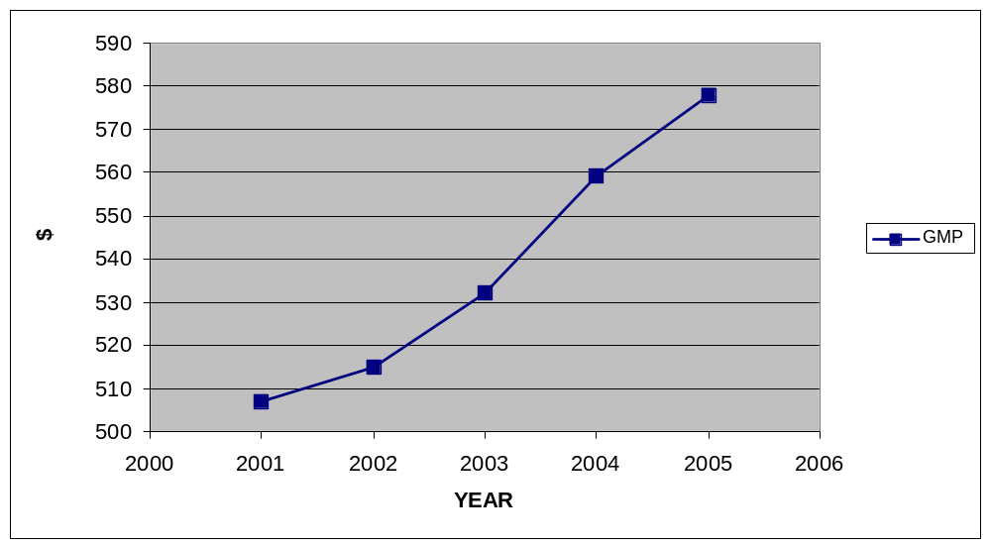Figure 10: Los Angeles' GMP
(in billions of U.S. Dollars)

Below is a graph of Los Angeles’ Green GMP from 2001-2005:
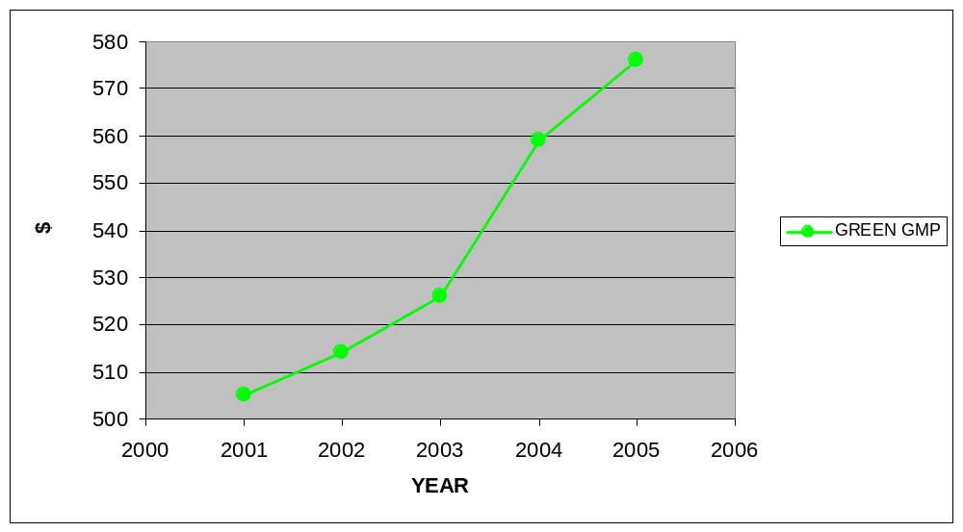Figure 11: Los Angeles' Green GMP
(in billions of U.S. Dollars)

Below is a graph of the cost of Los Angeles’ unplanned development from 2001-2005:
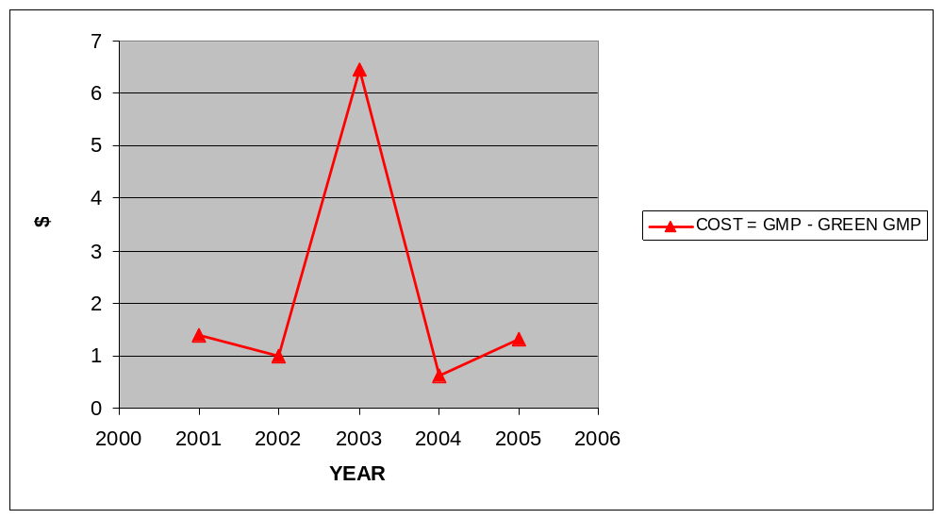Figure 12: Los Angeles' Cost of Development
(in billions of U.S. Dollars)

Recommendations
Los Angeles’ history of private influence upon development has helped it in some ways (attracting industry), yet hurt it in others (water and power).
Not surprisingly, both structure and infrastructure have nearly buckled under the resulting pressure. In the case of water, L.A.’s most famously scarce resource, intra-regional jealousies have traditionally been papered over by the ongoing common quest to import more water from elsewhere in the West. In the case of transportation, the struggle to build an urban rail system became, in part, a struggle over money between business leaders in downtown Los Angeles and politicians in outlying areas. And in the case of regional planning, local potentates have proven unwilling to yield parochial power.

The effects of Los Angeles’ major infrastructure investments are mixed. On the one hand, the port of Los Angeles and the airport claimed to support five hundred thousand regional jobs and 7 percent of the local economic activity in 1994, but on the other hand the gateways contribute to sprawl, significant air and water pollution, traffic congestion, and noise. This is one area in which Los Angeles cannot do much about, especially since the airport provides jobs and is needed in a world-class city. If Los Angeles focuses on smart growth policies, residents will end up saving money in the long run instead of spending it on last minute water and power purchases and the building of a transportation system after their residents are already addicted to the automobile.
There are no easy fixes for Los Angeles’ water, power, and transportation troubles. Growth is expected to continue at the rate of seven million over the next 25-30 years leading smart growth advocate and architect Peter Calthorpe to question, “How do you add two Chicagos to LA?” The best recommendation for curbing water and transportation problems is to create an urban growth boundary for Los Angeles in order to prevent future sprawl. Infrastructure spending spikes whenever a new housing development is built because money is spent on building pipes and providing water service to the developments. In addition, Los Angeles’ public transportation problems have begun to be addressed, but modal shift will take years before the mentality of the freeway is shifted towards using public transportation. The first hurdle of building an effective public transportation system still has not been jumped. Encouraging infill into the already massive land area encompassing greater Los Angeles is absolutely attainable. By setting up an urban growth boundary and encouraging infill, Los Angeles will help cut down on capital improvement projects expanding water services and transportation services to new areas and focus on the already built environment.
Privatization of water rights is something that residents of California must fight because the known effect is higher price and the unknown effect of bulk water transfers is scary. Companies are “responding to water scarcity by investing in water rights and land in order to sell it to the highest bidder,” which will only drive prices of an already scarce commodity higher. This then leads to companies trading water as a commodity, not a public good as it should be viewed, and bulk water transfers. The effects of bulk water transfers are unknown, but the results could be similar to what occurred with power during the energy crisis.
When it comes to energy, the power crises of the West Coast are also preventable. When the FERC encouraged local utilities to enter into long-term contracts for energy supplies during the Western Energy Crisis, yet refused to allow them to renegotiate the contracts afterward, legal action was taken by numerous companies. Today, FERC may have to “return to a case-by-case review of electricity contracts.” Despite past failures of the private sector, Los Angeles is well positioned to profit from its location if continued investment occurs from such companies as Iceland America Energy continues. Iceland America Energy, a subsidiary of Geysir Green Energy of Iceland, hopes to harness geothermal power (e.g. steam) and use it to power electricity producing turbines and heat homes in California. Using the experts in geothermal power from Iceland, a country that generates 26 percent of its energy from geothermal sources, to develop California’s geothermal options is promising especially since a state program to harness geothermal energy has existed since 1981 without much success. This endeavor is one example of how private companies, who helped create the sprawl that is common in Los Angeles today, could play a major role in building a new Los Angeles that produces its own energy.
In addition, Los Angeles is in dire need of a regional plan because it is a “fragmented metropolis a multi-headed beast with no center, with a system of urban organization that Easterners and Europeans couldn’t fathom.” Los Angeles is more regional than it has ever been and this could lead to more regional planning because all of the clusters realize they are interdependent.
Realizing they are interdependent is the first step toward regional planning but thus far regional planning has not occurred mostly because of three obstacles. First, “issues of transportation, land use, air quality, waste management, and housing are related yet are never addressed as a system. As a result, agencies cross-plan, cross-regulate, and neutralize each other’s initiatives.” These inefficiencies lead to an inefficient bureaucracy that blames each other for the overall failings. Second, EISs are a double-edged sword in California, slowing smart growth, yet also broadening the “understanding of the connection between pollution and public health and further intensity the debate.” Finally, the public continually stresses any plan put in place whether by objecting to tax increases, gentrification, class warfare and the impact of immigration, which leads to less funding for public programs. Selling smart growth to the public as cheaper is the best way to implement the aforementioned progressive policies.
With the influx of poorer Latin Americans, smart growth policies and their high upfront costs seem like they will not work. However, in comparison to the high costs of the current system they are the best option for Los Angeles. In conjunction with ending what William Fulton describes in his book The Reluctant Metropolis as “the politics of extraction,” taking resources away from poor areas to benefit rich areas, often practiced by the “growth machine,” an affordable housing option must be intertwined in any Los Angeles smart growth scheme.
The issues of housing and community development must be broadened into a regional and multisectoral planning process that deals systematically with employment, mass transit, land use, and environmental issues. Urban restructuring has had a turbulent effect on the jobs – housing balance, lengthening journeys to work in many outlying areas, clogging the freeways everywhere, and increasing pollution. Some way must be found to coordinate the many different sectoral agencies that deal with these issues to promote an integrated, yet flexible, approach to policy formulation and implementation in the larger metropolitan area, one that is responsive to local community needs. Transportation planning is likely to be a key to the success of such efforts, for a major investment of federal and local funds in mass transit development in Los Angeles is planned over the next thirty years – the largest direct public financial stimulus ever given to any metropolitan region. Ways to make this enormous investment benefit the entire region and use it to stimulate local economic development…

Fulton also argues that apathetic “cocoon citizenship” is destroying the Los Angeles megapolis. Even though there are many different cities making up the megapolis of Los Angeles, they need to accept that they are all tied together and must plan together in order to prevent disaster, he argues. This understanding is for the most part exactly what is needed in downtown Los Angeles as well – think regionally, not just for the benefit of Los Angeles proper (e.g. Owens Valley). If regional thinking were more prevalent, Los Angeles and Southern California would not be suffering as much as they are today.

IV. CHICAGO, ILLINOIS: TRANSPORTATION
With a GMP of $419 billion in 2005 and a strategic location between Lake Michigan and the Mississippi River, Chicago has come a long way from its beginnings in the early 19th Century.
In this chapter, the history of Chicago’s development is documented, sprawl’s effects on industry, water, power, and transportation are discussed, GMP and Green GMP calculations are compared, and recommendations for future development are made. It becomes clear that the economy of the area is hurt by the lack of transportation planning tying sister cities to the Chicago metropolis.

History of Development
The first settlers of Chicago in the early 1800s found it to be nothing spectacular, just as French explorers felt years earlier. An 1823 account wrote that the area “offers but few features upon which the eye…can dwell with pleasure” and the “uniformity in the scenery” was “fatiguing monotony.” These first impressions, however, did not give Chicago’s strategic location “in the lake, prairie, and river complex of the Middle West” its due. Meanwhile, the Native Americans who had been living in the area for centuries knew its importance all too well and many skirmishes were fought between new settlers and the natives leading up to the construction of Fort Dearborn in 1803 in order to guard the port link from Lake Michigan to the Mississippi River.
The construction of the Erie Canal in 1825 created another route for ships to reach the Midwest, besides the already established St. Lawrence River route. Ships would travel up the Hudson River from New York City, across the Canal, and into the Great Lakes. Chicago, as well as Buffalo, Cleveland, and Detroit, all benefited from this new route. Permanent settlement led to a rectangular grid city plan developed by James Thompson in 1830, based around the Chicago River.
Chicago began to develop rapidly into a major depot connecting the new Western lands with the East and had all of the elements that characterize a major metropolis by 1850. Population jumped from 50 in 1830 to 16,000 in 1847. Roads, based on old Indian trails sprung up, railroads were built, and the Illinois and Michigan Canal was opened in 1848. “Within a few decades after the first settlement, the spot where the river joined the lake would be the focus of commercial empires that dominated middle America and an industrial center whose products found markets throughout the world.” By 1870, Chicago had a population of 300,000 with plenty of developing industries such as iron and slaughtering the Midwest’s livestock providing jobs.
Suburbanization began early in Chicago, with suburbs popping up outside of the city limits as early as 1836, but continuing as the city grew. “As business facilities took over more and more of the downtown area, homesites had to found elsewhere.” As seen in the development of many other cities, the first to move away from the city were the wealthy, mostly to the West side and South side of the city. The North side had trouble attracting the wealthy because communications with the rest of the city were poor.
Lack of planning was evident as the working class settled in small lots without paved streets or sewers “unable to get away from the noise and odor of packing houses, tanneries, and distilleries” and continually crammed into the limited space available.
Despite this lack of planning, “the emerging residential pattern was shaped in large part by the development of local mass transportation. So long as the city was small and compact, people could walk to work or to where they wished to shop or visit.” The introduction of the horse-drawn omnibus was the first form of cheap mass transit and led more residents to move further away from the city. In addition, the new railroads contributed to settlement outside of the city.
Many attractive suburbs began to develop along mass transit lines and contributed to the multi-city development of the Chicago metropolis. Evanston, located 12 miles north of Chicago along two railways, was attractive to many because of its lakefront location, proximity to Chicago, and the founding of Northwestern University in 1851. Lake Forest, located 20 miles north, became the most exclusive suburb for the rich. To the West, Blue Island was served by 12 trains daily, transformed by subdivisions, and grew to 3,000 residents by 1874.
Meanwhile, city officials began improving conditions inside of the city and transformed the downtown area. Three questions persisted amongst city officials’ circles that showed how they genuinely were interested in planning the city: 1. how do we improve the streets?; 2. how do we provide water to the city?; and 3. how do we reserve land for park and recreational use?
The street question posed a large problem because the streets were built only slightly above sea level and drainage systems and plumbing continually failed. The options available to fix the problem included accepting the status quo or tearing down the city, building up its grade, and rebuilding it. The city officials came up with a plan in which to raise the grade for the entire city in 1855 and 1856, and then pave it. For the following two decades, “streets were raised, buildings were jacked up, and new drainage and paving were installed,” all without affecting many people or people even noticing at all.
Meanwhile, the water question, which still persists today, was addressed by creating a tunnel tap into the lake in 1867. Finally, building a park system for Chicago required much “persuasion” and they were built around public transportation hubs to be enjoyed by all. The parks question was solved by city officials who viewed the parks for the residents of Chicago and observed that, “The Parks first, and museums and libraries will follow.”
Development happened rather quickly within one lifetime, but it was largely erased even quicker. In 1871, the Great Fire of Chicago swept across the heart of the city, “destroying its whole commercial district, gutting most of its fine neighborhoods, and leaving a third of its people homeless.” Chicagoans quickly rebuilt, this time without any wooden buildings, and the fire actually accelerated trends that had begun prior to the fire including residential movement away from the city’s center, commercial and business establishments replacing housing developments downtown, and new dwellings being built on the outer edge of the city.
A “new” Chicago was born and cast in iron and brick. The “new business center was more elaborate and ornamental and, foreshadow[ed] Chicago’s skyscraping future, substantially higher.” Meanwhile in the industrial area, rebuilding kept pace with the business district. This “new” Chicago “created a distinctive urban form in the skyscraper, adopted radical innovations in mass transit, became the nation’s ‘second city’ with the addition of 120 square miles and 200,000 people, and solidified its industrial and commercial leadership of the middle continent.”
While growing vertically with the skyscraper, Chicagoland was growing horizontally with mass transit. When Chicago introduced San Francisco-esque cable cars, elevated steam railroads, and electric surface lines, it made it possible for more people to commute into the city for work in a reasonable amount of time. Mass transit projects were highly criticized because of the cost, but once the first cable cars became functional, nearly everyone became a supporter of the project. “The value of removing from a street the voiding of two or three thousand horses is a matter not to be lightly estimated in point of health... and the constant clatter of hoofs on the pavement is supplanted by the quiet gliding of a train, scarcely audible from the sidewalk,” said H.H. Windsor, the secretary of the Chicago City Railway.
Not satisfied with the streetcars, the South Side Rapid Transit Company began building elevated train lines in 1890 that carried passengers even faster. “Mid-twentieth-century commentators would use the phrase ‘exploding metropolis’ to convey the magnitude of the burst of urban expansion after World War II; but Chicago first exploded nearly a century before, with the introduction of new means of rapid transit.”
The elite began moving southward and westward, and other expansion took place most extensively along transportation lines that “radiated away from the central business district.” The South Side was the area of greatest expansion in the 1890s due to its transportation. Sub-division after sub-division sprung up and suburban growth continued unabated.
Even industry began moving outward with residential areas popping up outside industry. One example of suburban planning sprung up in 1883 called Pullman City, Chicago’s model suburban town. Designed as a moneymaker for its financier, George Pullman, the city had its public buildings grouped around public transportation, one of the first examples of a smart growth staple – transit oriented development (TOD).
The park across from the railroad station; residential blocks ran south; factory buildings were placed to the north and east. An attractive arcade provided convenient shopping facilities, and a theater, school, and church comprised a cultural compound at the city’s center. Workers’ dwellings were substantially built, if a bit snug; streets and alleys were paved, and trees and shrubs were planted before the houses were occupied. In addition, Pullman bought up much of the surrounding land to protect his planned community from the ravages of speculative development in the region…the central consideration of the scheme was to make labor more efficient and more productive by providing an environment conducive to work and improvement.

In 1893, Chicago held the “World’s Columbian Exposition” bringing in over 21 million visitors and the elevated (now known as the “el”) trains transported them extremely well. By 1907, cable cars gave way to street railways and invigorated the North side making it the more fashionable side of town. A new downtown Loop was created defining Chicago’s central business district and its center. By 1910, “the transit systems, elevated and surface, poured over three-fourths of a million people a day into the Loop area, with most of them arriving by surface streetcar.” Congestion increased and Chicago developed a rudimentary underground tunnel system by 1914.
The next stressor on congestion came with the automobile, but with both the city center and suburbs quite filled, there was no place to put additional residents. Chicagoans introduced the idea of industrial districts. “Under this scheme, the district acted like the residential developer, assembling land, laying out streets, and installing utilities.”
Industry and manufacturing began to follow residents to new areas and smaller cities popped up outside of Chicago. City planners were outraged because many of the new towns were built up without a plan by 1913. Urban experts chimed in scoring “the disorder, the dirt, and the planlessness, insisting that the city should be built according to rule – the streets of a certain width and arrangement, the population distributed in a definite way, and its institutions of a certain character.” Many prominent citizens joined the debate about city planning, forming a committee to “appraise the physical conditions of the city” and create a plan for the future of Chicago. The Merchants Club of 1906, later called the Commercial Club, came up with the famous Chicago Plan in 1909, which made the Chicago School famous.
The Chicago Plan was adopted in 1910 and shaped Chicago’s development for the next 50 years. It stressed “the betterment of commercial facilities; to methods of transportation for persons and for goods; to removing the obstacles which prevent or obstruct circulation; and to the increase of convenience.”
The end of World War I positioned Chicago for a new wave of growth. Chicago’s residents rallied around war efforts and with peace came a rapid expansion of growth. The 1920s shaped modern Chicago. The lakefront was developed, streets, parks, and boulevards were improved, bridges were built, a river branch was straightened, tracks were elevated, new university buildings and hospitals were built, industrial and commercial buildings were built and upgraded, and new hotels and theatres were built. On the downside a new ghetto in the South Side appeared and corruption became rampant in city politics. From 1920 to 1930, the population of Chicago had risen to 3.3 million, manufactured products and wholesale trade had risen 50 percent, consumption of electricity had risen 133 percent, and the number of automobiles driven in the city quadrupled.

The Plan of Chicago continued to drive Chicago’s expansion and Chicago’s Union Station was heralded as the most modern railway station in the world. This new station provided a beautiful environment for the newly developed fast diesel-powered trains. In order to handle the increase in population, apartment buildings became the home to many within the traditional city limits. However, this did not end urban expansion because suburbs were exploding in population as well and new suburbs rose out of vacant prairies. This suburban explosion was driven by the automobile, which allowed people to drive to the train station and then take the train to work.
Chicago was expanding laterally because “previously the population had to cluster around rail transport,” but now they could drive to the train station and take the train into work. Sub-dividers snatched up land and built on it creating instant suburbs. This trend provided a glimpse of what was to happen after World War II.
As often happens, commercial facilities followed residential facilities into the suburbs and city planners even encouraged this by reserving commercial space along new towns’ proposed main streets. In addition, “major outlying regional shopping centers” appeared and contained movie palaces, several banks, and large department stores, which also gave a glimpse into what future suburban life would be like. Industry also followed the residents and many set up plants outside of the traditional city boundary.
The Great Depression quickly halted this decade of progress. Expansion halted until city officials came up with a new Plan of Chicago, called the Master Plan of Residential Land Use in Chicago. This new plan took into account the popularity of the automobile and the increased use of the subway, but was put on hold because of World War II.
After World War II, most of Chicago’s new metropolitan development took place outside of “the old municipal limits; the suburban expansion drew away many of Chicago’s substantial taxpayers… as older middle class residents left for the suburbs, low-income newcomers took their place…while the suburbs flourished, the city languished.” This was the beginning of Chicago’s unplanned sprawl. Compounding the problems of the city center, the outlying suburban communities were too large and too powerful in state government. They resisted annexation, unlike in previous decades, by the city of Chicago, who needed their tax dollars in order to improve the city itself.
The key to Chicago’s redevelopment and recovery was Mayor Richard J. Daley. First elected in 1955, Daley “enjoyed cordial relations with business and labor” and fought to fix dilapidated houses, improve city medical services, overhaul the police department, install new alley and street lighting, modernize the fire department, and reward clean neighborhoods. However, improvements in race relations and public education were still a long time away.
Daley fought for a new urban renewal plan, but in the process ended up gentrifying dilapidated areas and displacing small businesses. The ghetto spread to the south as African-Americans moved into older apartment buildings left vacant by whites who, enjoying post-war prosperity, moved north. In the 1960s, a new skyline developed with each skyscraper larger than the previous one, many built higher just for a view of Lake Michigan.
The automobile continued to facilitate suburban expansion and by the middle 1950s almost every middle class family owned one.
With the building of modern expressways, it was possible to live sixty miles away form the Loop and still commute to work. As a result, a subtle shift took place inside the metropolis. The historic supremacy of the central city gave way to a new balance between the suburb and the city, with the future power moving increasingly toward the outer communities.

While the older suburbs centered on transportation hubs, the new ones relied on the automobile signaling the shift away from transit oriented development towards unplanned development. “The surge of population outward meant that shopping downtown became increasingly difficult. To serve this growing market, shopping centers sprang up throughout the suburbs… many were large, covering a quarter square mile of land in stores, plazas, and parking spaces.” Again, industry followed the residents outward. Heavy industry, dependent on water and rail transport did not move into the suburbs, but light industry took full advantage of the suburban trend. Expressways, often times funded by the federal government, also eased the shift to the automobile and allowed for lower density development. A major shift away from mass transportation occurred and even the introduction of express services could not shift it back.
Today, Chicago is still dealing with the unplanned development of post-World War II, but it is in much better shape than many cities because of its roots in planned development. However, Chicago’s development, no longer TOD based, has continued with more and more suburban cities meeting the definition of an edge city, marked by: 1. “five million square feet of leasable office space or more,” 2. “six hundred thousand square feet of retail space or more,” 3. “a population that increases at 9 A.M. on workdays – making the location as primarily a work center, not a residential suburb,” 4. “a local perception as a single end destination for mixed-use – jobs, shopping, and entertainment,” 5. “a history in which, thirty years ago, the site was by no means urban; it was overwhelmingly residential or rural in character.” Some edge cities include the Schaumburg area, the O’Hare Airport area, the Illinois Research and Development Corridor, and the Lake Shore Corridor area.

Effects on Industry
Chicago was developed because trade and industry flourished. Unlike New York City, Chicago’s development has generally not hurt industry. Chicago, like any major city in the world today, is host to every type of industry imaginable.
In sum, development’s effects on industry are few, and industry is thriving and not hurt by unplanned development.

Effects on Water and Energy
In contrast to industry, development’s effects on water and energy are more numerous. Water treatment and scarcity are major problems, but scarcity is nowhere near as problematic as in the “American Southwest, where very scarce water supplies have strictly limited growth.”
The importance of the region’s network of utilities in shaping suburban expansion cannot be overstated. In particular, the provision of sewers and related wastewater treatment services have largely defined when and where suburban expansion has occurred. In the Chicago area, local sewer systems are generally constructed by land developers and then dedicated to the municipality or county having local land-use jurisdiction… In some parts of the country, a popular strategy for containing urban sprawl is to create a regional authority to determine the limits of wastewater service areas in keeping with an overall growth strategy… but the Illinois EPA recently announcing its intention to eliminate the concept of facility planning areas (FPAs), which means that there will be no state or regional oversight in northeastern Illinois respecting the expansion of suburban growth through the extension of wastewater services except for the Illinois Commerce Commission’s regulation of private utilities. Clearly, a comprehensive state policy is needed with respect to governing the extension of wastewater services and such related matters as storm-water management, water supply, the protection of critical open spaces, the premature development of prime agricultural lands, and the containment of suburban sprawl.

As population grew, Chicago’s ability to obtain, treat, and manage water was hurt due to rapid population growth.
In the 1880s, a drainage canal movement, which represented a determined effort to obtain pure drinking water and safe sewage disposal, arose in Chicago… The large financial outlay made for Chicago’s water system, sewer network, and drainage canal reflected the community’s commitment to new responsibilities. This canal permanently reversed the flow of the Chicago River from Lake Michigan into the Mississippi River system…built at a cost of $45 million, the canal marked a significant commitment by Chicago to procuring pure water and guarding public health.

The rapid expansion caused many municipal problems; most serious was the disposal of waste. Untreated sewage was dumped into Lake Michigan and frequent epidemics of water-borne diseases occurred. Chicago responded by building a canal across the drainage divide between Lake Michigan and the Mississippi basin to handle storm runoff and spread out and break down sewage. Eventually the Chicago River was rerouted to flow into the Mississippi River, rather than into Lake Michigan in order to dump sewage into the Mississippi River rather than Lake Michigan.
The next step in dealing with unplanned development was making the water drinkable. “Chlorination was a major step in assuring Chicagoans of pure drinking water. The city began experimenting with chlorination in 1912 and by 1916 had applied it to the entire water supply. This practice drastically cut the threat of typhoid and other waterborne diseases.”
Finally, in 1947, Chicago solved the problem of water with the introduction of filtration. “The South District Filter Plant began providing filtered water to South Side Chicagoans in 1947. In 1964 the city opened its Central Water Filtration Plant, having the largest processing capacity in the world.”
Today, Chicago still has water problems and some problems are dealt with by some of the tenets of the famed Chicago Plan that were not acted on in the early 20th Century. For example, “The Greenway system builds on a major recommendation of the Burnham Plan, namely the protection of the several major water-related corridors through acquisition of hundreds of small strategically located plots throughout the metropolitan area.”
When it comes to power, Chicago’s utilities are mainly provided by Commonwealth Edison, known as ComEd. Chicago generally does not have the energy problems the American Southwest and West runs into because of its central location within the American power grid.

Effects on Transportation
At first, Chicago developed as a transit oriented city, but slowly moved away from its roots. Although the omnibus gave way to cable cars and cable cars gave way to steam railroads and the “el,” none of these shifts affected life in Chicago as much as the automobile. Suburban residents began driving to train stations to take mass transit into Chicago, as many New York suburbanites did, but before long they stopped parking at the station to ride in – they just continued to drive into Chicago for work. In addition, Chicago’s development of sister cities each with their own industrial and commercial bases that offered jobs, led to development that broke the centrifugal force of Chicago since not all residents had to commute to Chicago for work. This shift also led to more public opposition towards expensive mass transit construction. Chicago’s lack of transportation infrastructure spending has undoubtedly hurt the area, but the city could spring back and appears to be doing so.
In 1943, Chicago opened its first subway. The reason it took so long was Chicago’s soft subsoil made up of watery clay. However, public support for the expensive project was the primary reason for the delay; if a city can reroute a river, a city can undoubtedly build a subway.
In 1974, the Regional Transportation Authority was created for the six counties of Northeastern Illinois. The Regional Transportation Authority is made up of the Chicago Transit Authority (CTA), which runs the rapid transit (subway system), the Pace, which is the suburban bus system, and Metra, which is the heavy commuter rail system that runs all the way to South Bend, Indiana.

GMP v. Green GMP
The cost of Chicago’s unplanned development is rising based upon the difference between GMP and the calculated Green GMP. In particular, transportation is costing Chicago millions of dollars that could have been used in other arenas if they had planned for the projects being funded today.
Chicago’s unplanned development average cost per year was $704.4 million per year, which is zero percent of the GMP. In support of the hypothesis, Chicago’s GMP and Green GMP did display a positive correlated relationship, but were virtually the same thereby minimizing the cost of unplanned development in comparison to total GMP. Also in support of the hypothesis that unplanned development’s costs will increase over time, the cost grew ranging from $221 million in 2001 to $954 million in 2002. The null hypothesis was rejected.
Despite all hypotheses being supported, unplanned development’s costs were relatively low. However, as shown earlier, Chicago’s environment, open space, transportation options, and traffic were affected greatly by this form of development.
Data for environmental protection and cleanup could not be found for Chicago. Below is a table, measured in thousands of U.S. Dollars, encompassing the findings from 2001-2005:
YEAR | GMP | INFRASTRUCTURE | WATER & ENERGY | GREEN GMP | COST OF DEVELOPMENT
2001 | 396279000 | 198000 | 23000 | 396058000 | 221000
2002 | 396764000 | 934702 | 20100 | 395809198 | 954802
2003 | 404222000 | 831239 | 25100 | 403365661 | 856339
2004 | 414209000 | 847097 | 26800 | 413335103 | 873897
2005 | 419187000 | 591967 | 24000 | 418571033 | 615967
Table 3: Data and Calculations for Chicago

Below is a graph of Chicago’s GMP from 2001-2005:
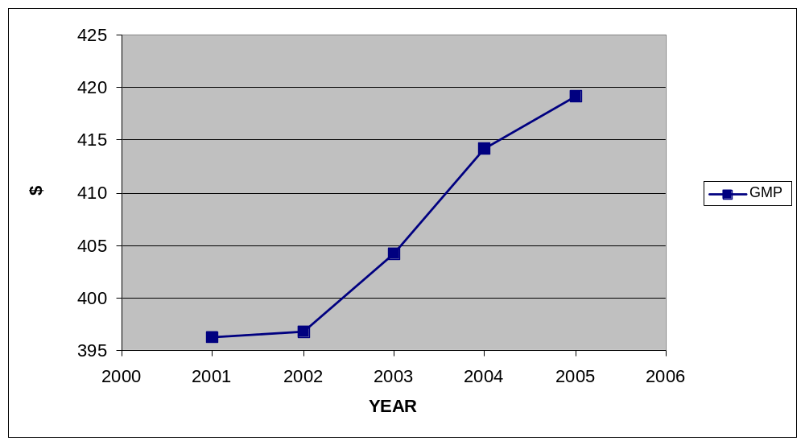Figure 13: Chicago's GMP
(in billions of U.S. Dollars)

Below is a graph of Chicago’s Green GMP from 2001-2005:
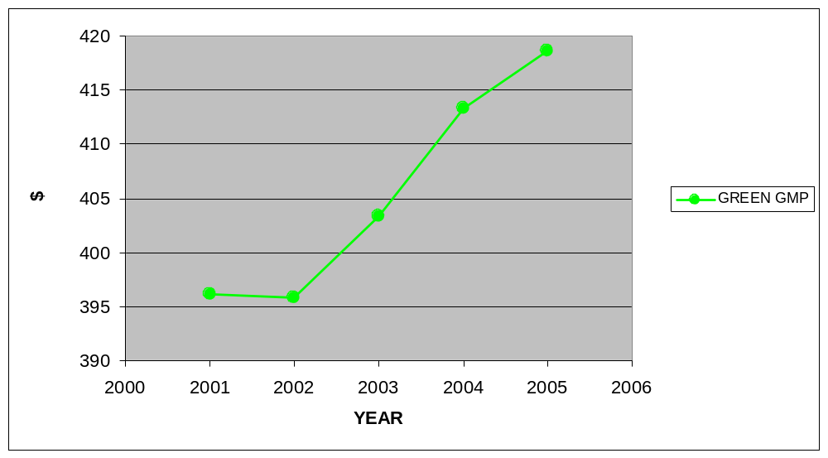Figure 14: Chicago's Green GMP
(in billions of U.S. Dollars)

Chicago spends an average of $704.4 million on water and power and transportation per year, which represents the cost of unplanned development. Transportation spending through capital improvements is the main cause of the spike in spending between 2001 and 2002. Chicago had to rehab its Blue Line, design a new Brown line, purchase an automated bus announcement system, and attempt to modernize its aging bus and rail fleet. In particular, design of the Brown line is something that would not have been necessary had transportation spending and transit oriented development had continued after the post-World War II population explosion.
Below is a graph of the cost of unplanned development in Chicago:
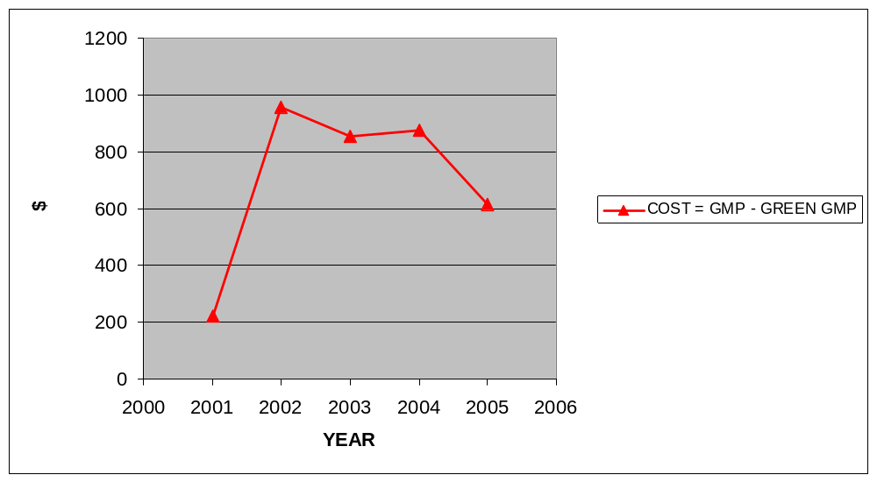Figure 15: Chicago's Cost of Development
(in millions of U.S. Dollars)

Recommendations
Chicago’s lack of transportation planning is what is primarily driving up the cost of unplanned development. Today, Chicago is considering whether or not to expand its mass transit options in order to ease congestion in and around Chicago due to its sister city development pattern. Chicago is planning a bold 65-mile inter-suburb rail system, called the STAR line, to be run by the Metra regional rail agency. The STAR line will allow travel between suburbs without having to travel into the city – the equivalent of a mass transit beltway. Chicago’s population growth and job growth has primarily occurred in the suburbs and the inter-suburb rail system could help cut down on automobile use. If ridership is high and development continues, the $1.2 billion price tag may prove to be a bargain and could ease the congestion on the Northwest Tollway. Despite the plans, Chicago area mayors could not get the idea included in the region’s 2020 transportation plan. The main reason for its exclusion is the residents have not seen the results of the billions of dollars already spent on plans for the on-again off-again proposal for the Crosstown Expressway, “new expressways and rapid transit service” being built but “acute traffic problems remain[ing] and may[be] even be getting worse.”
In addition to building the STAR line, more regional coordination is needed, as recommended in the 2020 Chicago Plan, to “deal effectively with the interrelationships among policies and practices concerning transportation, land use, housing, and the environment… we recommend that the State of Illinois establish a Regional Coordinating Council (RCC).”
The proposed STAR line will not become any cheaper with time and could serve as a way to steer the Chicago area back towards transit oriented development. Rather than clogging up roadways to travel a few miles, the STAR line will enable residents to travel from suburb to suburb and open up mass transit accessible job opportunities in sister cities. In addition, the STAR line could contribute to preventing further sprawl and the infrastructure costs associated with building on open space. Water pipelines will not have to be extended and precious water will not be wasted in further expansion.

V. PORTLAND, OREGON: PLANNED CITY
While Los Angeles is often cited as the penultimate example of sprawl, Portland is cited just as often as the best example of a city using planning techniques in order to control sprawl.
In this chapter, the history of Portland’s development is documented and GMP and Green GMP calculations are compared in order to have a planned control city to compare to unplanned cities. It becomes clear that the economy of the area is linked to its planning techniques and is proactive in dealing with problems while maintaining a stable Green GMP.

History of Development
Portland and the state of Oregon are often cited as waging “the longest running, most extensive, best-documented, and most controversial assault on sprawl in this country…[because] many Oregonians wanted to avoid at all costs… becoming ‘another Los Angeles.’”
First settled because of its arable land, location between the Willamette and Columbia Rivers, and proximity to the Pacific Ocean, Portland was incorporated in 1851. Portland grew primarily as a West Coast port and railroad town, but was surpassed by Seattle as the major Pacific Northwest port once Seattle’s deepwater port was adequately developed in the late 19th Century.
Portland followed a similar development pattern as many other middle sized cities, with a population boom after World War II. With this boom, came sprawl, but outraged citizens worked to control it.
In 1973, Oregon Governor Tom McCall, a Republican, oversaw the passage of the Land Conservation and Development Act, which established an urban growth boundary that has shaped Portland’s development ever since. The act required every town, city, and county, to plan their respective growth and improvements in accordance with statewide goals. In order to supervise this, the act set up the Land Conservation and Development Commission (LCDC).
After the act was passed, the Metropolitan Service District (Metro) drew up an urban growth boundary for Portland. The boundary had little effect on Portland early on because there seemed to be plenty of land within it and Portland originally had a low density, much to the chagrin of smart growth advocates. Yet, by the 1990s, development was booming and many argued to extend the growth boundary. Residents fought a new bypass and argued for transit oriented development in which populations would be centered on transit hubs and still keep downtown Portland as a centrifugal force on the area. The Metro made a compromise by adopting TODs and extending the growth boundary, but also building the bypass.
Skeptics of Portland say that density has not increased enough, population and job growth is occurring more at the periphery than in the city center, prices have been driven upwards, and the new rail system is used by too few people to warrant money being taken away from the roads and buses more people use.
The fact of the matter is the urban growth boundary has, for the most part, accomplished its goal of limiting sprawl and keeping the city somewhat dense. Some argue over whether or not the boundary actually is responsible for this result, or if it was many of the other schemes Portland has put in place, but the boundary is the key element that is absent in many of the other cities in America. In addition, by diverting more money towards public transportation rather than roads as density increases more people will use public transportation.
Within the past 10 years, “a good deal of the building…both in existing neighborhoods and at the suburban edge, has been denser and more compact than previous decades,” but problems still exist in Portland. “The results of anti-sprawl policies have demonstrably not stopped the outward spread of people and jobs, and they may well have aggravated the very things, for example, highway congestion, that they were supposed to alleviate.”
Today, Portland is continuing on its track of progressive development. Currently, Portland is experimenting with new “green” roofs that are designed to soak up storm water and cool buildings cutting down on runoff and lowering the urban temperature and the need for extra energy used by overworked air conditioners. In addition, forward thinking transportation planning continues “as transit planners are discovering, you can mitigate the costs of rail if you can find existing tracks that will meet your needs. In the Washington County suburbs of Portland, Oregon, for instance, the regional transportation agency, TriMet, is making steady progress on a five-station, suburb-to-suburb line using existing freight tracks.”

GMP v. Green GMP
With an average GMP of $91 billion, Portland is not as big of an economic powerhouse as New York City, Los Angeles, or Chicago, but it serves as a good example of a planned community.
Data for Portland is based upon the adopted Portland City Budgets from 2001 to 2005. Data for the “Infrastructure” column comes from the budget of the Office of Transportation, which details the spending for transportation, street lighting, and parking facilities. Data for the “Water and Power” column comes from the Public Utilities section of the Portland City Budget, which encompasses the budgets of the Bureau of Environmental Services and Bureau of Water Works. The Public Utilities section of the budget includes spending on the sewer system, hydroelectric power, environmental mitigation, water, and solid waste treatment. Since the data for the “Water and Power” column also includes the budget of the Portland Environmental Remediation Division, which oversees environmental clean up, there is no need to use a separate “Environment” column for Portland.
Portland’s planned development’s average cost was $445 million per year, which is zero percent of GMP. In support of the hypothesis, Portland’s GMP and Green GMP did display a positive correlated relationship. Also, in support of the hypothesis the cost was relatively stable and indicative of a planned city. Unlike New York, Portland does not have any foreseeable shocks that will cost its GMP $6 billion. The null hypothesis was also rejected.
Despite all hypotheses being supported and planned development’s costs being relatively low compared to Los Angeles and Chicago, development costs were higher than New York’s primarily because it has a smaller GMP and New York’s industry loss has not been fully realized.
Below is a table, measured in thousands of U.S. Dollars, encompassing the findings from 2001-2005:
YEAR | GMP | INFRASTRUCTURE | WATER & ENERGY & ENVIRONMENT | GREEN GMP | COST OF DEVELOPMENT
2001 | 77181000 | 110300 | 248100 | 76822600 | 358400
2002 | 78424000 | 117700 | 268900 | 78037400 | 386600
2003 | 79893000 | 128500 | 346100 | 79418400 | 474600
2004 | 87591000 | 153800 | 346700 | 87090500 | 500500
2005 | 91060000 | 172700 | 332200 | 90555100 | 504900
Table 4: Data and Calculations for Portland

Below is a graph of Portland’s GMP from 2001 to 2005:
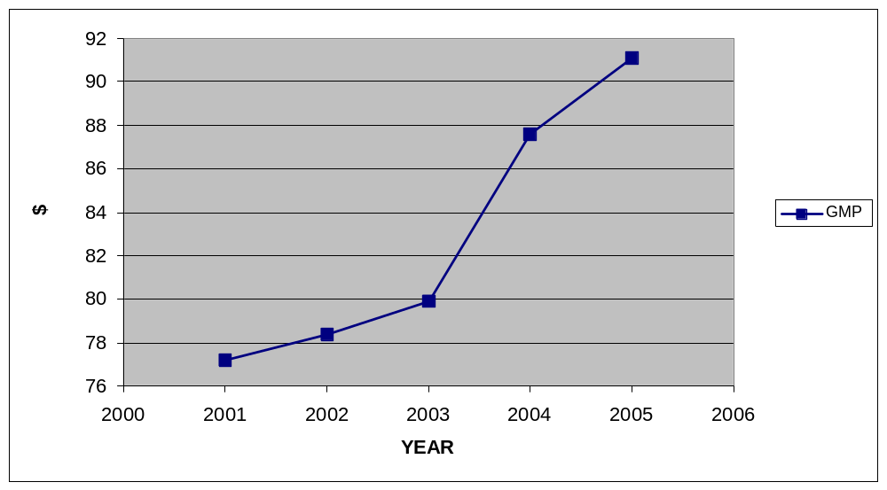Figure 16: Portland's GMP
(in billions of U.S. Dollars)

Below is a graph of Portland’s Green GMP from 2001 to 2005:
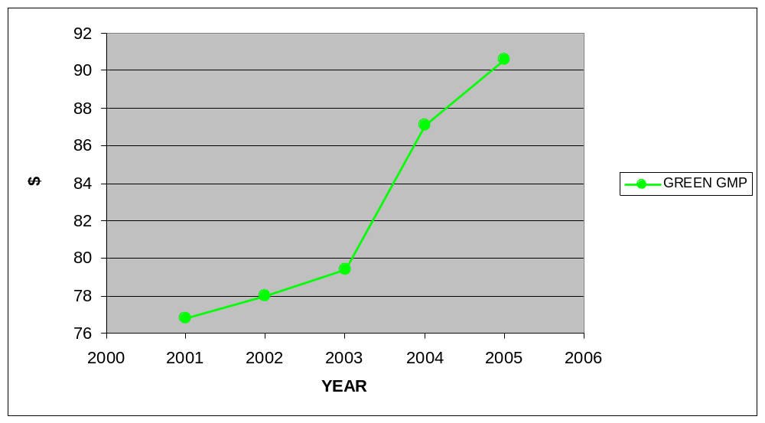Figure 17: Portland's Green GMP
(in billions of U.S. Dollars)

Below is the cost of development in Portland based on subtracting Green GMP from GMP from 2001 to 2005:
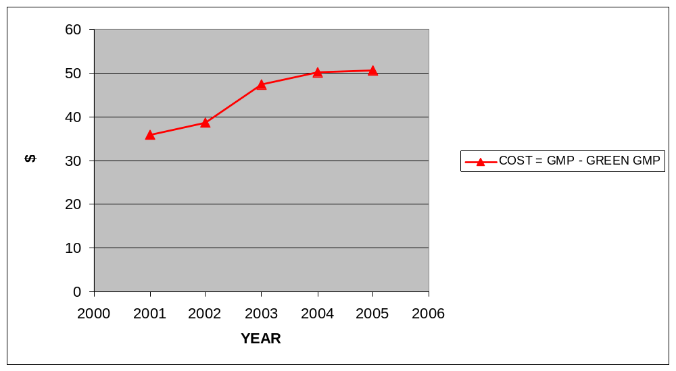Figure 18: Portland's Cost of Development
(in millions of U.S. Dollars)

VI. CONCLUSION
Although there is a correlated relationship between the cost of development as defined by this paper and planned and unplanned development, it is not as strong a correlation as hypothesized. The data does support the hypothesis that planned development (Portland) costs less than unplanned development (New York, Los Angeles, Chicago). However, the cost of unplanned development is not in the multibillion-dollar range predicted in the introduction.
The reason for this unexpected result is twofold. First, the GMPs of the cities analyzed are relatively high. For example, New York, Los Angeles, and Chicago, rank respectively first through third in GMPs of cities in the United States. The large GMPs, ranging from Portland’s low GMP in 2001 of $77.1 billion to New York’s high in 2005 of $973.5 billion, means that a cost of even $2.1 billion, as Los Angeles averaged, is still 0 percent of the average GMP of $537.6 billion per year. This 0 percent difference is evidenced in the graphs for GMP and Green GMP – they look like identical. Second, only five years were studied. If GMP data were available from 1800, perhaps a more pronounced pattern would have developed and it may have been similar to the hypothesized graphs over time. Put simply, the hypothesis could be totally correct and the five years examined are a part of the leveled off/declining GMP/Green GMP hypothesized. In addition, despite the apparent failure in New York, the industry loss is still not fully realized and at any time a total ecosystem collapse of the Long Island Sound could push New York’s Green GMP down an estimated $6 billion per year thus proving the hypothesis. Right now, unplanned development in New York causes an underlying instability and does not cost a great deal, but New York is metaphorically on thin ice.
As this thesis advocates, creating an alternative to the standard GDP-based GMP now being fine-tuned by the U.S. Department of Commerce’s Bureau of Economic Analysis is a valid and important goal. Unplanned development falsely boosts GMP, does not account for its monetary or environmental cost, and, in fact, costs more than planned development. An alternative Green GMP would account for these false gains and losses. After BEA finishes creating historical GMP data then these questions can be revisited with better data sets to arrive at more definitive answers.
This thesis also set up three factors that are affected by unplanned development (industry, water and energy, and transportation) and describes the impact development has on municipal GMP. Despite not being directly compared to each other on the same factor, each city’s Green GMP was calculated using the same factors. Each city did experience shock in areas other than the primary factor studied. For example, New York’s spending on sewage treatment increased, Chicago’s spending on water increased, and Los Angeles’ spending on transportation increased despite being examined and chosen as a case study because of other factors.
The only way smart growth policies will be enacted on a large scale will be by attacking its opponents’ best argument – that unplanned development costs less right now. Proving that smart growth will save the taxpayer money over time is the best way to shift the debate towards environmental damage and the problems with sprawl. It is the best way to sell smart growth and this thesis made strides to do exactly that. Shifting the debate will also help to reorient economic thought towards macroeconomic ecological economics that views the Earth as a provider of limited natural capital. For years environmental issues have polled as very important to a majority of Americans, but when it comes down to paying extra money in taxes or paying to enter a congested city due to congestion pricing, the electorate balks at the notion. Optimizing a municipal budget through planning does cost less and contributes to shifting the debate toward saving money – something that every citizen approves of.
At the heart of the matter is the fact that Americans are addicted to the automobile and are also convinced that the economy must always grow. Both of these political culture attributes must shift in order to better serve the nation and the world.
Herman Daly, an ecological economist who favors the widespread use of economic indicators that take environmental damage into account, argues that, “Growth in GNP is so favored by economists that they call it ‘economic’ growth, thus ruling out by terminological baptism the very possibility of ‘uneconomic’ growth in GNP.” Many economists worship at the altar of microeconomic growth, but fail to realize that at some point growth is not possible since what happens at the macroeconomic level is “transforming…(natural capital) into itself (man-made capital).”
By attempting to put a cost on GMP growth, the slow process of teaching the American collective that “the economic activities of human beings are related to the natural world – an ecosystem which is finite, non-growing, and materially closed” is advanced. A shift in vision must occur to replace the growth at all costs mentality. “The economics of development without – and beyond – growth needs to be worked out much more fully.”
The term ‘economic growth’ has in practice meant growth in gross national product. All problems are to be solved, or at least ameliorated, by an ever growing GNP. It is the only magnitude in all of economics that is expected to grow forever – never to reach an economic limit at which the marginal costs of further growth become greater than the marginal benefits… The macroeconomy is not seen as part of anything larger – rather it is the whole…

However, this is not the case as the economy is a “subsystem of a larger finite and non-growing ecosystem, and consequently that the macroeconomy too has an optimal scale.” All of the goods being traded, produced, consumed, and used, are making GNP “grow” but all they are doing are being converted from raw materials into wastes. This is the main tenet behind a steady-state economy (SSE). A SSE “can develop, but cannot grow, just as the planet earth, of which it is a subsystem, can develop without growing.”
Environmental economics, as it is taught in universities and practiced in government agencies and development banks, is overwhelmingly microeconomics. The theoretical focus is on prices, and the big issues is how to internalize external environmental costs to arrive at prices that reflect full social marginal opportunity costs.

Meanwhile, macroeconomics does not deal with the environment and “GNP growth is thought to be independent of natural resources.” In this thesis, an attempt was made to show that GMP growth is not independent of natural resources.
A push towards a new economic indicator including environmental harm is not just a political policy issue and could receive support from religious organizations just as other “moral” issues have. This push, from the political realm to the morality realm, recently occurred when Pope Benedict XVI recently characterized damage to the environment as a form of one of the seven deadly sins – gluttony. It has also been evident in Asia, where Buddhist influence is heavy and Buddhist economics does not take into consideration growth or stagnant growth, but finding the “Middle Way” and the “Right Livelihood.”
Many arguments against shifting the growth debate exist, such as the following:
One of the most popular arguments against limiting growth is that we need more growth in order to be rich enough to afford the costs of cleaning up pollution and discovering new resources. Economist Neil Jacoby says, ‘A rising GNP will enable the nation more easily to bear the costs of eliminating pollution.’

Cumulative Findings: Cost of Development
 | NEW YORK | LOS ANGELES | CHICAGO | PORTLAND
2001 | $28,378,000 | $1,389,900,000 | $221,000,000 | $358,400,000
2002 | $30,705,000 | $1,002,026,000 | $954,802,000 | $386,600,000
2003 | $32,797,000 | $6,459,438,000 | $856,339,000 | $474,600,000
2004 | $34,570,000 | $629,208,000 | $873,897,000 | $500,500,000
2005 | $35,518,000 | $1,320,135,000 | $615,967,000 | $504,900,000
Average per year | $32.4 million | $2.1 billion | $704.4 million | $445 million
Table 5: Comparison of the Cost of Development

Problems and Limitations
Oversimplification of development’s cost is problematic. Data was gathered from budgets rather than broken down even further into detailed subsets. The data was then subtracted from GMP data that is cutting edge (the first GMP data ever released by the Department of Commerce was used in this thesis). In addition, it is hard to compare the cities with each other since each is affected more so by one factor than another. Since most cities are affected by numerous stressors, a fusion city should have been examined in this thesis in order to provide a good comparison, but was not. For example, the Washington, DC, metropolitan area is cited by some as planned, but is affected by industry loss through pollution of the Chesapeake Bay (e.g. loss of oyster industry, and blue crab industry), the lack of transportation planning execution (e.g. implementation of the purple line connecting Silver Spring, MD, to Bethesda, MD, and the Dulles Metro Extension), and edge city development of Bethesda/Chevy Chase, Silver Spring, White Flint, Rockville, Shady Grove, Gaithersburg, Germantown, Columbia, Landham-Landover-Largo, Laurel, and Bowie, in Maryland, and Rosslyn-Ballston, Crystal City, Old Town Alexandria, Tysons Corner, Reston, Leesburg, and Gainesville, in Virginia, just to name a few.
Critics will argue that sprawl is in fact planned development – development planned by market forces that favor the automobile over public transportation, large lot zoning, and residential development outside of center city. This thesis uses a strict definition of planned and unplanned development as outlined in the introduction, but still, the argument that sprawl is in fact planned is still a valid counterview. In addition, critics will argue that the adoption of Green GMP is unrealistic and will discount the need to view growth and shift the public policy debate on development towards a more regional, global view. Although the adoption of Green GMP is a hard sell, by arguing that planned development costs less, smart growth advocates are able to move out of the corner they have been backed into by market-based planners who continually jab at smart growth as expensive and uneconomic. Perhaps the adoption of Green GMP will not occur until regular GMP is affected, but this thesis argues to adopt Green GMP earlier in order to prevent that scenario.
Despite the limitations of this thesis, it remains the opinion of this paper that if in fact sprawl is planned then it is poorly planned because of the environmental damage, often irreversible, done to areas where sprawl is rampant, and this environmental damage actually costs more than just aesthetics and quality of life. While sprawl may indeed seem planned in the microeconomic sense as opponents of this thesis claim, they must then argue that the environmental and economic damage at the macro level was planned as well, argue that environmental damage is irrelevant, or argue that growth is good at any cost. All three arguments are flawed and unpopular and all allow smart growth advocates to paint critics as ignorant and lacking foresight.
Although limited in scope, this paper discusses major development issues of relationships that are “notoriously complex and has resisted precise qualification over decades of research.”

Policy Recommendations
Besides the recommendations already made for each specific city, the use of GMP data and the development of a reliable Green GMP must occur. In order to address the problems of development, at the national level the United States must: 1. integrate planning and zoning regionally, 2. implement policies that discourage the use of the automobile, 3. increase forward-thinking infrastructure spending, not reactionary spending, 4. increase alternative energy research and development funding, and 5. shift the public policy development debate towards adopting a GDP model that accounts for environmental damage and shows true growth.
First, the integration of planning and zoning regionally is quite a challenge since “local sovereignty in land use matters has been established and reinforced consistently since the seminal 1926 U.S. Supreme Court decision that declared local zoning constitutional. In Village of Euclid v. Ambler Realty Co., 272 U.S. 365 (1926), the Court recognized the principle of local self-determinism in land use control.” Even when rezoning affects other townships, courts have found that one township does not have to factor into their plan the effects their zoning would have on neighboring townships [e.g. Bedford v. Mount Kisco, 33 N.Y.2d 178, 306 N.E.2d 155 (1973)]. Given that the courts have sanctioned local governments’ power to plan (bottom-up planning), how then can the state and federal governments regionally plan from the top down? This is the major question facing smart growth advocates because planning at the regional level should cut down on natural resources being exhausted and prevent “unlimited low-density development entails infrastructure costs that are far higher per capita than for more compact developments” and help preserve open space.
The only way in which to get around the established system is through bottom-up change since top down regional planning is virtually non-existent and “it is the legislative and regulatory actions of those governments that dictate how much of the land is covered with impervious surfaces; how many miles of roads are built; how many septic systems, sewer plants, and water systems are created; and where buildings and improvements are located.”
One way to help bottom-up change is through the Community Leadership Alliance Training Program. This program, funded by Congress, trains “local leaders in land use strategies, intermunicipal cooperation, and community-based decisionmaking…a recent opinion survey of graduates regarding the results of their training indicates satisfaction and success rates of over 90%.” Success of this program is promising since it shows that townships can negotiate and mediate disputes in order to create a quasi-regional plan, in the absence of a state planning board only present in Alaska, California, Florida, Idaho, Maine, Oregon, and Washington. This bottom-up approach also encourages public participation and public dialogue ensuring that all views are heard across municipalities. Green GMP data showing that planned development costs less than unplanned development will only help motivate people interested in saving money to become involved in policy formulation and eventually policy implementation of smart growth. Local governments could also create “zoning and financial incentives…to cluster homes, jobs, and services along public transport corridors.”
Bottom-up change begins with planning at the local level, which is usually done through zoning, and will eventually lead to regional planning and top-down planning. Since local governments are given broad powers to zone, local governments make the main decisions affecting development. The best smart growth strategies include a good site plan, allowing a certain amount of development of every form in a parcel of land with businesses allowed to transfer rights between each other within the parcel, discouraging development in certain areas in order to focus development in areas in which it is cheap and easy to provide infrastructure for, and redeveloping brownfields.
Brownfield redevelopment has many positive effects on urban areas including “restoring neighborhoods, bringing back jobs, cleaning up abandoned factories, and converting eyesores into assets.” In addition, there are many energy benefits associated with redeveloping brownfields including less electrical line-loss due to the proximity of structures, less energy spent on building up brownfields than starting from scratch in suburbia, the opportunity to develop waste-to-energy programs like Baltimore’s trash burning being converted into building heat (which lowers greenhouse gas emissions), and the retention of greenfield carbon sinks. Brownfields also encourage infill and environmental cleanup, which benefit the area by lowering greenhouse gas emissions from automobiles because vehicular miles traveled is lower in compact developments, and brownfields are often superfund sites that are cleaned up prior to being redeveloped to the benefit of area residents.
Zoning should be done with the area’s comprehensive plan in mind, and then from the comprehensive plan the regulations affecting development are developed. This is because courts can strike down regulations if there is no comprehensive plan in place.
Zoning takes many forms. Overlay zoning protects environmentally sensitive areas and often takes the form of a conservation area overlay district (CAOD) in which critical areas are identified and planning is done in accordance with other development in order to protect that area. Recreational zoning limits land uses to activities such as golf, tennis, and equestrian events.
The regulations put in place also govern land use by dictating how zoning is administered and managed. Subdivision regulations divide lots for the purpose of development and sale in a detailed fashion. The American Planning Association recommends including strict EIS requirements for any subdivision. This ensures cost effective development. Site plan regulation usually is not encompassed under subdivision rules and should contain specific regulations regarding the development of gas stations, office parks, and apartment buildings. Cluster development is a form of subdivision regulation which requires subdivisions to consist of smaller lots, setbacks, yards, concentrate development on the smallest amount of land possible, and maximizes open space. It “offers economic advantages by reducing the need for new roads, water and sewer lines, and public services such as snow removal or road maintenance.” Studies have found that “compact development patterns that consume less land to accommodate population expansion produce 40% less water pollution and significantly reduce the number of trips taken by car and associated air emissions and greenhouse gases.” Through specific regulations of zoning, land can be conserved and habitats preserved.
The general rule of regulation is the more specific the better. Regulation in the form of local ordinances can protect aquifers, fish and wildlife habitats, ridgelines, trees and timber, wetlands, provide floodplain protection, control erosion, and manage storm water runoff. These types of regulations can also serve as a preventative measure that mitigates any damage done by a natural disaster before it occurs.
Another tool of local governments is the strategic acquisition of open lands either through purchasing the title, purchasing development rights, or leasing development rights. Purchasing the title means that the local government now owns it, but it then loses the tax revenue from the owner it purchased the property from. Purchasing development rights are perpetual, but the owner still must pay taxes on the land. Finally, leasing development rights are for a period of time and the owner still must pay taxes on the land.
Local governments must also ensure that transportation planners work with city planners, rather than working in separate offices from city planners. Instead of a division of work in which city planners deal with zoning and land-use regulation and transportation planners deal with mass transit, city planners and transit planners should work in tandem in order to create a comprehensive plan at the local level. This would also force city planners to think outside of their own city and take into account links to other townships by using mass transit. During the planning process, city and transit planners must also consider capital improvements as a last resort and think ahead rather than react to problems. A campaign must occur ensuring that smart growth policies are not branded as “elitist and hurting the less affluent parts of the population” – any smart growth plan should also have a public housing project within it.
At the local level, private industry also plays a role and integration is key to ensuring effective planning policy. Although there have been mixed results, private industry must play a role in any step forward toward achieving metropolitan sustainability because “the world is becoming an increasingly urban place.” One way in which the United States can improve her cities is to use China as an experiment. There are plenty of opportunities in the 1.3 billion strong People’s Republic of China to experiment with private industry. For example, private companies are exporting municipal solid waste management consultants and many other professionals to advise China on their environmental problems. These companies will now have a pool of knowledgeable consultants that could end up returning to the United States and advising municipalities on how to deal with environmental problems in the United States, which, for the most part, are not as bad as in China.
Second, the American addiction to the automobile must be treated by implementing policies that discourage the use of the automobile. “European cities are living proof that a high standard of living is compatible with a reduced need for cars,” but in America a high standard of living is expected to include a nice automobile. The main reason this association continues is “the hidden costs of driving, such as air pollution, municipal services, and road construction and repair” are subsidized by the government. “External costs of motor vehicle use that are not directly in user charges to drivers amount to about $300 billion per year, more than 5 percent of the country’s GDP.” The best way to break the addiction is through congestion pricing, once thought politically dead, but increasingly becoming a more plausible option to cut down on congestion. Recently, possibly signaling a shift away from congestion pricing outrage, the National Capital Region introduced a plan to implement a region wide series of tolls on highways and bridges using “E-ZPass-like transponders” to bill motorists. This plan was introduced without as much backlash as would be expected and if adopted it is estimated to generate $2.75 billion per year. In addition, the Bush administration has pressed forward with plans to privatize roads meaning that business entities would have to pay for their upkeep but would also be allowed to charge a toll for their use. Having users pay for road upkeep puts a price on driving and should also affect trucks more heavily because they do the most damage to the roads. Acceptance of tolls and congestion pricing is becoming more common which may be a good step towards breaking America’s addiction to the automobile. According to Sigurd Grava, professor of urban planning at Columbia University, “Highway space is a scarce resource, and if it is scarce, we have to manage it. In a market economy, this means pricing.”
Another way to shift Americans away from the automobile and the harmful runoff it causes is through parking and tax reforms in which employers who offer free parking must also offer a public transit option of equal value.
Acknowledging the fact that Americans are addicted to the automobile is also a fact that must be calculated for. Automobiles are here to stay which means that research must be done in order to power them by the best fuel source possible. Currently there are six alternative sources to gasoline for automobile use. They are methanol, hydrogen, electricity, ethanol, biodiesel, and compressed natural gas. The most promising is hydrogen, but it is not yet fully developed and transporting it is a safety concern. Continuing research into hydrogen fuel cells is a must, especially since many of the agriculturally based fuel options use power to make power. In addition to researching alternative fuel sources, gasoline’s true price must be felt by the average addicted American through the use of higher fuel taxes and increased truck taxes.
Third, Congress, as agenda setters and policy formulators, must begin to shape the debate and increase infrastructure spending. Numerous energy, water, and transportation issues have yet to be addressed. One example of what Congress could do is setting a progressive national railroad policy that could propel the United States to the levels of Germany and Japan who both have an extensive network of high-speed railroads. In theory, new maglev trains could travel at speeds of up to 500 miles per hour, making them a particularly attractive option for travelers arriving in one of the major international airports that usually sit in hour long traffic jams while attempting to get into the city center of Chicago or Manhattan. In addition, transportation issues are often pushed to the back burner in Congress and even in the presidential campaign. Despite bridges collapsing in Minnesota, and a report from the National Surface Transportation Policy and Revenue Study Commission saying “the federal government must spend $225 billion a year on transportation infrastructure for a half-century to build the kind of transportation system the nation needs to stay competitive,” Congress and presidential candidates alike refuse to push for it.
Infrastructure spending also must be increased in order to improve the nation’s electrical grid. The grid is over a century old, subject to overload, different in different parts of the country, not centrally planned, insecure and vulnerable to terrorist attack, and inefficient. Major blackouts have occurred recently, the most notable the Northeast Blackout of 2003, which cost an estimated $6 billion in lost business.
When it comes to water, some argue that there is a “global water crisis” that is in part caused by “inappropriate economic incentives for water use and insufficient social institutions and legal frameworks for water management.”
Alternative energy development and funding must be increased in order to wean the American public off of hydrocarbons, which most likely will have national security benefits in addition to the known environmental benefits. Geothermal, wind, research into harnessing energy from ocean currents, and perhaps revisiting the nuclear energy debate may prove to be beneficial to aiding the energy hungry United States. Despite biofuels’ promise, the crops associated with producing biofuels are in part responsible for the “global water crisis.” Corn, used for ethanol and in high-fructose corn-syrup, “may be cheap in the supermarket, but in the environment it could not be more expensive,” according to Michael Pollan, author of In Defense of Food: An Eater’s Manifesto. Pollan argues that because of the fertilizer used on corn crops in the Midwest, a “dead zone in the Gulf of Mexico, an area the size of New Jersey where virtually nothing will live because it has been starved of oxygen by the fertilizer runoff coming down the Mississippi River from the Corn Belt” has been formed.
Finally, as stated earlier, the public policy debate must be shifted towards planned development costing less than unplanned development in monetary value and environmental effects. The best way to do this is to adopt a Green GDP model on the national level and Green GMP model at the municipal level – both of which will show true growth within the steady-state environment and subtract the false gains of unplanned growth. Placing the complex urban planning debate, one that involves every aspect and agency of municipal government, into simple terms – planning costs less than sprawl – may break the indecision and stasis that the late New York Sen. Daniel Patrick Moynihan lamented about during his career.

Topics for further research and development
With the advent of GMP at the BEA, a whole new realm of economic data is available to be tested. This thesis’ attempt at placing a cost on development could be expanded on to definitively prove that planned development is the best way to go forward into the 21st Century. The only way to sell smart growth to the policy makers and the public is to prove that it is financially and environmentally better. Models using Green GMP/GMP data may become so accurate that the marginal cost for one block of new sewage pipe could be calculated making municipal governments more efficient. This could lead to further analysis of sprawl in which sprawl’s utility is examined. Sprawl would probably exhibit a diminishing marginal utility due to infrastructure spending and environmental damage, but that is a topic for further research.
Further research will hopefully lead to policy changes in each city discussed and across the nation and world. In addition, further research on a different indicator than the basic Green GMP used in this paper measuring cost of development would help shift the debate from maximizing growth at all costs versus less growth to sustainable growth versus unsustainable growth. GMP in itself is a relatively new field with the data being used having just been released by the Bureau of Economic Analysis (BEA) in September 2007. The BEA is creating more historical GMP data as this thesis is being written, and hopefully will create historical GMPs. Ideally, this thesis would have been able to graph GMP data since the establishment of the city and analyze data over many years rather than five years. Undoubtedly, this thesis would have benefited from GMP data from 1800 to present. For example, the oyster and lobster industries in New York would have presented a larger percentage of goods and services produced in 1800 than it does now that the industries are almost extinct and New York has grown to a megapolis with a almost a trillion dollar per year GMP.
Hopefully the method of accepting that GMP will continually grow in an area with sprawl, but then also subtracting the false gains, will become the norm. This method shows how part of the growth being accounted for in GMP is for an environmentally hazardous way of life. Another area of further research is the development of an even more revised economic indicator of a city’s economic and environmental health including subtracting harm to any public good (e.g. policing costs, roads, health, education) from GMP.
This research reaches for the stars just as city planners have reached since the beginning of time. Closing with an optimistic Daniel H. Burnham quote, as Mayer and Wade closed Chicago: Growth of a Metropolis, seems fitting given the present stacked deck against planned development, ecological economics, and amidst a suffering global ecosystem. Burnham’s prescience still applies today in a world where sacrifice is mocked and where turning a blind eye towards complex problems is the norm: “Make no little plans; they have no magic to stir men’s blood and probably will not be realized. Make big plans, aim high in hope and worth, remembering that a noble, logical diagram once recorded will never die, but long after we are gone will be a living thing, asserting itself with ever-growing insistency. Remember that our sons and grandsons are going to do things that would stagger us.”
Bibliography
Altshuler, Alan, and David Luberoff. Mega-Projects: The Changing Politics of Urban
Public Investment. Washington: Brookings Institution Press, 2003.

Andersen, Tom. This Fine Piece of Water : An Environmental History of Long Island
Sound. New Haven: Yale University Press, 2002.

Bruegmann, Robert. Sprawl. Chicago: The University of Chicago Press, 2005.

Brusendorff, Anne C. “Case Study: The Success of Regional Solutions in the Baltic.”
Sustainable Development Law & Policy (Vol. VII, Issue 1). Washington: American University Washington College of Law, Fall 2006.

Burchell, Robert W., Naveed A. Shad, David Listokin, Hillary Phillips, Anthony Downs,
Samuel Seskin, Judy S. Davis, Terry Moore, David Helton, and Michelle Gall.
Costs of Sprawl - Revisited. Washington: Transportation Research Board, 1998.

U.S. Department of Commerce - Bureau of Economic Analysis. “BEA Introduces New
Measures of the Metropolitan Economy.” 26 September 2007. Accessed 12 December 2007 at http://bea.gov/newsreleases/regional/gdp_metro/gdp_metro_newsrelease.htm

Calthorpe, Peter M. The Next American Metropolis. New York: Princeton
Architectural Press, 1993.

. “New Urbanism: Principles or Style?” In New Urbanism, by Robert Fishman.
Ann Arbor: University of Michigan, 2005.

Caro, Robert A. The Power Broker: Robert Moses and the Fall of New York. Ann
Arbor: University of Michigan, 1974.

Crawford, Margaret. “Everyday Urbanism.” In Everyday Urbanism, by Rahul Mehrotra.
Ann Arbor: University of Michigan, 2005.

Cutler, Irving. Chicago: Metropolis of the Middle Continent. Carbondale, IL: Southern
Illinois University Press, 2006.

Daly, Herman E. Beyond Growth. Boston: Beacon Press, 1996.

. Ecological Economics and the Ecology of Economics. Northampton,
MA: Edward Elgar, 1999.

. Steady-State Economics. Washington: Island Press, 1991.

DeCorla-Souza, Patrick. “Los Angeles, Other Cities, Use Toll Roads as a Congestion-
Management Tool.” In Cities and Cars, by Roger L. Kemp. Jefferson, NC:
McFarland & Company, Inc., 2007.

Duany, Andres, Elizabeth Plater-Zyberk, and Jeff Speck. Suburban Nation : The Rise of
Sprawl and the Decline of the American Dream. New York: North Point Press,
2000.

The Economist. “Birth, Death and shopping.” 19 December 2007.

Einhorn, Catrin. “Traffic Money for N.Y. May Benefit Other Cities.” The New York
Times, 30 April 2008, A12.

U.S. Environmental Protection Agency. “Effects of Different Types of Development on
the Environment.” Our Built and Natural Environments: A Technical Review of
the Interactions Between Land Use, Transportation and Environmental Quality
(January 2001): pp. 35-79.

Erie, Steven P. Globalizing L.A. Stanford: Stanford University Press, 2004.

Ewing, Reid. “Is Los Angeles-Style Sprawl Desirable?” Journal of the American
Planning Association (Winter 1997): pp. 107-119.

Feehan, David, and Marvin D. Feit. Making Business Districts Work. New York: The
Haworth Press, 2006.

Fishman, Robert, ed., New Urbanism. Vol. II of Michigan Debates on Urbanism, by
Douglas Kelbaugh. Ann Arbor: University of Michigan, 2005.

Fulton, William. The Reluctant Metropolis. Baltimore: The Johns Hopkins University
Press, 2001.

Garreau, Joel. Edge City: Life on the New Frontier. New York: Doubleday, 1991.

Gerbasi, Jennifer C. “The Next Privatization of Public Assets: Domestic and Trade
Implications Related to Water Right and Land Acquisition.” Sustainable
Development Law & Policy (Winter 2005): pp. 23-29.

Gottlieb, Robert, Mark Vallianatos, Regina M. Freer, and Peter Dreier. The Next Los
Angeles. Los Angeles: University of California Press, 2005.

Gordon, Peter, and Harry Richardson. “Are Compact Cities a Desirable Goal?” Journal
of the American Planning Association (Winter 1997): pp. 95-106.

Gurwitt, Rob. “Chicago Area Officials Explore Suburb-to-Suburb Public Transit Links.”
In Cities and Cars, by Roger L. Kemp. Jefferson, NC: McFarland & Company,
Inc., 2007.

Haberstroh, Joe. “Dying Industry.” Newsday, 6 October 2004, A48.

Harrison, Longmire. “Merging Environmental and Energy Sustainability With
Opportunities for U.S. Corporations.” Sustainable Development Law & Policy
(Spring 2007): pp. 53-56.

Hartman, Eviana. “High Fructose Corn Syrup: Not So Sweet for the Planet.” The
Washington Post, 9 March 2008, N02.

Hughes, Sara, Lena Partzsch, and Joanne Gaskell. “The Development of Biofuels Within
the Context of the Global Water Crisis.” Sustainable Development Law & Policy
(Spring 2007): pp. 58-62.

Itkowitz, Colby. “Transportation Issues Go to Back of Campaign Line.” CQ Today, 02
April 2008.

Jablonski, Thomas R. “New York City’s Subway Century.” TR News (January-
February 2006): pp. 3-7.

Johnson, Elmer W. Chicago Metropolis 2020. Chicago: The University of Chicago
Press, 2001.

Katz, Peter. The New Urbanism: Toward an Architecture of Community. New York:
McGraw-Hill, Inc., 1994.

Kelbaugh, Douglas, ed., Michigan Debates on Urbanism (Vol. I-III). Ann Arbor:
University of Michigan, 2005.

Kelbaugh, Douglas. Repairing the American Metropolis: Common Place Revisted.
Seattle: University of Washington Press, 2002.

Kelly, Barbara M. Expanding the American Dream: Building and Rebuilding Levittown.
Albany: State University of New York Press, 1993.

Lambert, Bruce. “In Middle Age, L.I. Suburbs Show Wear.” The New York Times, 12
February 2004, B1.

Layton, Lyndsey, and Spencer S. Hsu. “Letting the Market Drive Transportation.” The
Washington Post, 17 March 2008, A1.

Lerup, Lars. “American Speed, American Distance.” In New Urbanism, by Robert
Fishman. Ann Arbor: University of Michigan, 2005.

Levine, Jonathan. Zoned Out. Washington: Resources for the Future, 2006.

Life Magazine. Life: In Hollywood. 2003. Accessed 12 April 2008 at
http://www.life.com/Life/lifebooks/hollywood/intro.html

Long Island Power Authority. “2007 Long Island Population Survey.” Uniondale:
November 2007.

Lowe, Marcia D. “Cars, Their Problems, and the Future.” In Cities and Cars, by Roger
L. Kemp. Jefferson, NC: McFarland & Company, Inc., 2007.
MacKenzie, James J., Roger C. Dower, and Donald D.T. Chen. The Going Rate: What it Really Costs to Drive. Washington: World Resources Institute, 1992.
Marshall, Alex. “The Future of Transportation.” In Cities and Cars, by Roger L. Kemp. Jefferson, NC: McFarland & Company, Inc., 2007.
Matejka, Kristen. “Long Island Convention & Visitors Bureau and Sports Commission Names New President.” LICVB&SC Press Release, 04 August 2004. Accessed 10 March 2006 at http://www.licvb.com/pr_detail.cfm?ID=4&group_ID=6
Mayer, Harold M., and Richard C. Wade. Chicago: Growth of a Metropolis. Chicago:
University of Chicago Press, 1969.

McKinney, John. “Should Long Island quit New York and become a state?” The Village
Beacon Record, 24 April 2008, A23.

Mehrotra, Rahul, ed., Everday Urbanism. Vol. I of Michigan Debates on Urbanism, by
Douglas Kelbaugh. Ann Arbor: University of Michigan, 2005.
National Oceanic and Atmospheric Administration. “Annual Landing Reports 2001-2005.” Accessed 15 March 2008 at http://www.st.nmfs.noaa.gov/
New York Seafood. Accessed 20 March 2006 at http://www.newyorkseafood.com

New York State Office of the State Deputy Comptroller for the City of New York.
“Review of the Mayor’s Executive Budget for NYC, Fiscal Year 2001.” Albany: New York State Government Printing, 2000.

. “Review of the Mayor’s Executive Budget for NYC, Fiscal Year 2002.” Albany:
New York State Government Printing, 2001.

. “Review of the Mayor’s Executive Budget for NYC, Fiscal Year 2003.” Albany:
New York State Government Printing, 2002.

. “Review of the Mayor’s Executive Budget for NYC, Fiscal Year 2004.” Albany:
New York State Government Printing, 2003.

. “Review of the Mayor’s Executive Budget for NYC, Fiscal Year 2005.” Albany:
New York State Government Printing, 2004.

Nolon, John R. Open Ground: Effective Local Strategies for Protecting Natural
Resources. Washington: Environmental Law Institute, 2003.

. Well Grounded: Using Local Land Use Authority to Achieve Smart Growth.
Washington: Environmental Law Institute, 2001.

O’Connell, James C. Chicago’s Quest for Pure Water. Washington: Public Works
Historical Society, 1976.

Paull, Evans. “Energy Benefits of Urban Infill, Brownfields, and Sustainable Urban
Redevelopment” (Working Paper). Washington: Northeast Midwest Institute,
April 2008.

Pedersen, Daniel. E-mail interview by John Mooney, 25 April 2006.

Peterson, George E., and Patricia Clarke Annez. Financing Cities. Los Angeles: Sage
Publications, 2007.

Piper, Karen. Left in the Dust. New York: Palgrave, 2006.

Pisarski, Alan E. “Commuting Flow Characteristics.” Commuting in America II.
Washington: The Eno Transportation Foundation, 1996.

Office of the Mayor of Portland. “Portland City Budget FY 2001-2002.” Accessed 15
March 2008 at http://www.portlandonline.com/omf/index.cfm?c=26699

. “Portland City Budget FY 2002-2003.” Accessed 15 March 2008 at
http://www.portlandonline.com/omf/index.cfm?c=27448

. “Portland City Budget FY 2003-2004.” Accessed 15 March 2008 at
http://www.portlandonline.com/omf/index.cfm?c=27917

. “Portland City Budget FY 2004-2005.” Accessed 15 March 2008 at
http://www.portlandonline.com/omf/index.cfm?c=32934

. “Portland City Budget FY 2005-2006.” Accessed 15 March 2008 at
http://www.portlandonline.com/omf/index.cfm?c=38357

Sea Grant Project (SUNY-Stony Brook). “Long Island Lobsters.” Accessed 11 March
2006 at http://www.seagrant.sunysb.edu/LILobsters/

Schaller Consulting. “Commuting, Non-work Travel and the Changing City.” Brooklyn:
June 2002.

Schumacher, E.F. “Buddhist Economics.” In Valuing the Earth, by Herman E. Daly and
Kenneth N. Townsend. Cambridge: The MIT Press, 1993.

Scott, Allen J., and Edward W. Soja. The City. Los Angeles: University of California Press, 1996.

Speaks, Michael. “Every Day is Not Enough.” In Everday Urbanism, by Rahul
Mehrotra. Ann Arbor: University of Michigan, 2005.

Stefan, Chris. “Fueling the Future: A Policy-Based Comparison of Alternative
Automotive Fuel Sources.” Sustainable Development Law & Policy (Spring 2007): pp. 22-24.

Strickland, Roy, ed., Post Urbanism & ReUrbanism. Vol. III of Michigan Debates on
Urbanism, by Douglas Kelbaugh. Ann Arbor: University of Michigan, 2005.

Suffolk County Planning Commission. “Meeting Minutes from February 1, 2006”
Accessed 13 March 2006 at http://www.co.suffolk.ny.us

Tobier, Emanuel. “New York Region Thrives on Complex Public Mass transit
Options.” In Cities and Cars, by Roger L. Kemp. Jefferson, NC: McFarland &
Company, Inc., 2007.

Tweit, Susan J. “Raising the Roof.” Audubon (March-April 2008): pp. 40-42.

Verhovek, Sam Howe. “Power Shortage Sends Ripples Across the West.” The New
York Times, 17 December 2000, A1.

White, Louise G. Political Analysis: Technique and Practice. Belmont, CA:
Wadsworth/Thomson Learning, 1999.

Wiggins, Lucy. “The Ninth Circuit Confronts the Aftermath of the Western Energy
Crisis.” Sustainable Development Law & Policy (Spring 2007): pp. 63-64.

Wiland, Harry, and Dale Bell. Edens Lost & Found. White River Junction, VT: Chelsea
Green Publishing Company, 2006.
Weigold, Marilyn E. The Long Island Sound: A History of Its People, Places, and
Environment. New York: New York University Press, 2004.

Weiss, Eric M. “Report Suggests New Tolls For Region.” The Washington Post, 17
March 2008, B1.
Curriculum Vita
John Christopher Mooney was born in Bronx, NY, on February 2, 1981.
Mooney received a Bachelor of Arts in Journalism and Political Science from The George Washington University in May 2003. Upon graduation, Mooney was commissioned as an artillery officer in the U.S. Army and served on active duty until June 2007. Currently, Mooney works as a paralegal in the Antitrust Division of the U.S. Department of Justice.

Published work:
Schmidt, Jeffrey S., and John C. Mooney. “TAB in the Fires Brigade: FA and ADA?”
Fires Bulletin (May/June 2007): pp. 13-16. Available at: http://sill-www.
army.mil/firesbulletin/2007/May_Jun_2007/May_Jun_2007_pages_13_16.pdf

Burchell et al., The Costs of Sprawl, 6-7.
Calthorpe, The Next American Metropolis, 16-7.
Ewing, “Is Los Angeles-Style Sprawl Desirable?” 118.
White, Political Analysis, 127-28.
Ibid., 131.
Ibid., 141.
White, Political Analysis, 283.
Bruegmann, Sprawl, 96-112.
Scott and Soja, The City, 25.
Bruegmann, Sprawl, 117.
Ibid., 122.
Ibid., 127.
Ibid., 123.
Bruegmann, Sprawl, 139.
Ibid., 175.
Peterson and Annez, Financing Cities, 311.
Ibid., 331.
Ibid., 332.
Feehan and Feit, Making Business Districts Work, 413.
Ibid., 420.
Ibid., 414.
The Economist, “Birth, death and shopping.”
Feehan and Feit, Making Business Districts Work, 16.
Ibid., 33.
Ibid., 414.
Ibid., 12.
Feehan and Feit, Making Business Districts Work, 33.
Levine, Zoned Out, 2.
Ibid.
Bruegmann, Sprawl, 17-8.
Scott and Soja, The City, 79.
Bruegmann, Sprawl, 17.
Levine, Zoned Out, 16.
Ibid., 2.
Ibid., 3.
Levine, Zoned Out, 5.
Ibid., 7.
Ibid., 18.
Ibid., 11.
Ibid., 17.
Bruegmann, Sprawl, 190.
Ibid.
Levine, Zoned Out, 109.
Mayer and Wade, Chicago, 276.
Speaks, “Every Day Is Not Enough,” 34.
Ibid.
Lerup, “American Speed, American Distance,” 40.
Kelbaugh, New Urbanism, 8.
Calthorpe, “New Urbanism: Principles or Style?” 16.
Ibid., Errata 35-6.
Crawford, “Everyday Urbanism,” 22.
Ibid., 25.
Kelbaugh, Repairing the American Metropolis, 171.
Kelbaugh, Repairing the American Metropolis, 171.
Ibid., 173.
Erie, Globalizing L.A., 205.
Tobier, “New York Region Thrives on Complex Public Mass transit Options,” 138.
Long Island Power Authority, “2007 Long Island Population Survey,” iii.
Ibid., v.
Lambert, “In Middle Age, L.I. Suburbs Show Wear,” B1.
Weigold, The Long Island Sound, 9.
Ibid., 37.
Ibid., 50.
Weigold, The Long Island Sound, 95.
Andersen, This Fine Piece of Water, 101.
Weigold, The Long Island Sound, 95.
Andersen, This Fine Piece of Water, 102.
Ibid.
Ibid., 104.
Andersen, This Fine Piece of Water, 106.
Weigold, The Long Island Sound, 163.
Kelly, Expanding the American Dream, 56.
Kelly, Expanding the American Dream, 44.
Kelly, Expanding the American Dream, 26.
Ibid., 31.
Andersen, This Fine Piece of Water, 105.
Scott and Soja, The City, 83.
Kelly, Expanding the American Dream, 29.
Caro, The Power Broker, 897.
Weigold, The Long Island Sound, 156.
Andersen, This Fine Piece of Water, 106.
Weigold, The Long Island Sound, 153.
Ibid., 154.
Ewing, “Is Los Angeles Sprawl Desirable?” 109.
Ewing, “Is Los Angeles Sprawl Desirable?” 109.
Ibid.
Gordon and Richardson, “Are Compact Cities a Desirable Goal?” 98.
Andersen, This Fine Piece of Water, 82-95.
Ibid., 95.
Ibid., 99.
Andersen, This Fine Piece of Water, 111.
Ibid., 122.
Ibid., 108.
Andersen, This Fine Piece of Water, 122.
Ibid., 124.
Ibid., 128.
Andersen, This Fine Piece of Water, 129.
Ibid., 143.
Ibid., 132.
Ibid., 145.
Sea Grant Project.
Haberstroh, “Dying Industry,” A48.
New York Seafood.
Ibid.
Sea Grant Project.
Matejka, “LICVBSC Names New President.”
Andersen, This Fine Piece of Water, 158.
Ibid., 164.
Ibid., 166.
Andersen, This Fine Piece of Water, 6.
Andersen, This Fine Piece of Water, 113.
Andersen, This Fine Piece of Water, 105.
Caro, The Power Broker, 897-98.
Jablonski, “New York City’s Subway Century,” 7.
U.S. EPA, “Effects of Different Types of Development on the Environment,” 54.
U.S. Department of Commerce, “BEA Introduces New Measures of the Metropolitan Economy.”
Andersen, This Fine Piece of Water, 7.
New York State Office of the State Deputy Comptroller for the City of New York, “Review of the Mayor’s Executive Budget for NYC, Fiscal Year 2001.”
New York State Office of the State Deputy Comptroller for the City of New York, “Review of the Mayor’s Executive Budget for NYC, Fiscal Year 2002.”
New York State Office of the State Deputy Comptroller for the City of New York, “Review of the Mayor’s Executive Budget for NYC, Fiscal Year 2003.”
New York State Office of the State Deputy Comptroller for the City of New York, “Review of the Mayor’s Executive Budget for NYC, Fiscal Year 2004.”
New York State Office of the State Deputy Comptroller for the City of New York, “Review of the Mayor’s Executive Budget for NYC, Fiscal Year 2005.”
National Oceanic and Atmospheric Administration, “Annual Landings Reports 2001-2005.”
Lambert, “In Middle Age, L.I. Suburbs Show Wear,” B1.
Schaller Consulting, “Commuting, Non-work Travel and the Changing City.”
Pisarski, Commuting in America II, 65.
Ibid., 63.
Tobier, “New York Region Thrives on Complex Public Mass transit Options,” 141.
Duany et al., Suburban Nation, 138.
MacKenzie et al., The Going Rate, 10.
Ibid., 23.
MacKenzie et al., The Going Rate, 25.
Einhorn, “Traffic Money for N.Y. May Benefit Other Cities,” A12.
McKinney, “Should Long Island quit New York and become a state?” A23.
U.S. EPA, “Effects of Different Types of Development on the Environment,” 60.
Lambert, “In Middle Ages, L.I. Suburbs Show Wear,” B1.
Brusendorff, “Case Study: The Success of Regional Solutions in the Baltic,” 64.
Scott and Soja, The City, 1.
Bruegmann, Sprawl, 203.
Scott and Soja, The City, 22.
Ibid., 76.
Ibid.
Ibid., 85.
Fulton, The Reluctant Metropolis, 99.
Scott and Soja, The City, 86-7.
Ibid., 88.
Ibid., 5.
Ibid., 89.
Scott and Soja, The City, 89.
Ibid., 90.
Erie, Globalizing L.A., 51.
Scott and Soja, The City, 5.
Scott and Soja, The City, 90.
Ibid., 91.
Ibid., 92.
Scott and Soja, The City, 108.
Ibid., 94-5.
Ibid., 115.
Fulton, The Reluctant Metropolis, 9.
Scott and Soja, The City, 9.
Ibid., 16.
Fulton, The Reluctant Metropolis, 48.
Katz, The New Urbanism, 217.
Gottlieb et al., The Next Los Angeles, 107.
Fulton, The Reluctant Metropolis, 11-2.
Life Magazine, Life: In Hollywood.
Fulton, The Reluctant Metropolis, 6.
Ibid., 104.
Gottlieb et al., The Next Los Angeles, 110.
Fulton, The Reluctant Metropolis, 109.
Ibid., 105.
Piper, Left in the Dust, 4.
Ibid., 140.
Scott and Soja, The City, 189.
Fulton, The Reluctant Metropolis, 106.
Wiland and Bell, Edens Lost & Found, 141.
Fulton, The Reluctant Metropolis, 106-7.
Piper, Left in the Dust, 151.
Piper, Left in the Dust, 152.
Ibid., 151-2.
Ibid., 165.
Ibid., 166.
Ibid., 13.
Piper, Left in the Dust, 140.
Ibid., 52.
Ibid.
Ibid., 82.
Ibid., 61.
Piper, Left in the Dust, 78-9.
Ibid., 170-1.
Ibid., 173.
Ibid., 174.
Ibid.
Fulton, The Reluctant Metropolis, 60.
Ibid.
Ibid., 102.
Piper, Left in the Dust, 53.
Fulton, The Reluctant Metropolis, 104.
Scott and Soja, The City, 190.
Verhovek, “Power Shortage Sends Ripples Across the West,” A1.
Scott and Soja, The City, 136.
Gottlieb et al., The Next Los Angeles, 106.
Ibid.
DeCorla-Souza, “Los Angeles, Other Cities, Use Toll Roads as a Congestion-Management Tool,” 107.
Ibid., 106.
U.S. Department of Commerce, “BEA Introduces New Measures of the Metropolitan Economy.”
Fulton, The Reluctant Metropolis, 100.
Erie, Globalizing L.A., 215.
Ibid., 216.
Calthorpe, “New Urbanism: Principles or Style?” 19.
Gerbasi, “The Next Privatization of Public Assets,” 23.
Wiggins, “The Ninth Circuit Confronts the Aftermath of the Western Energy Crisis,” 63.
Fulton, The Reluctant Metropolis, 10.
Scott and Soja, The City, 38.
Ibid., 39.
Fulton, The Reluctant Metropolis, 97.
Scott and Soja, The City, 18.
Mayer and Wade, Chicago, 3.
Ibid., 4.
Ibid., 2.
Mayer and Wade, Chicago, 14.
Ibid., 12.
Ibid., 18.
Ibid., 30.
Ibid., 26.
Ibid., 3.
Ibid., 35.
Ibid., 24.
Ibid., 56.
Mayer and Wade, Chicago, 62.
Ibid., 66.
Ibid., 74.
Ibid., 90.
Mayer and Wade, Chicago, 94.
Ibid., 96.
Ibid., 98.
Ibid., 100.
Ibid., 102.
Mayer and Wade, Chicago, 106.
Ibid., 118.
Ibid.
Ibid., 127.
Ibid., 138.
Mayer and Wade, Chicago, 138.
Ibid., 142.
Ibid., 144.
Ibid., 154.
Ibid., 188.
Mayer and Wade, Chicago, 214.
Ibid., 234.
Ibid., 251.
Ibid., 272.
Mayer and Wade, Chicago, 274.
Ibid., 276.
Ibid.
Ibid., 283.
Ibid., 290.
Mayer and Wade, Chicago, 326.
Ibid.
Ibid., 344.
Ibid., 346.
Mayer and Wade, Chicago, 375-6.
Ibid., 376.
Mayer and Wade, Chicago, 418.
Ibid., 422.
Garreau, Edge City, 425.
Ibid., 428.
Bruegmann, Sprawl, 208.
Johnson, Chicago Metropolis 2020, 62.
O’Connell, Chicago’s Quest for Pure Water, 1.
Mayer and Wade, Chicago, 272.
Ibid., 274.
O’Connell, Chicago’s Quest for Pure Water, 18.
O’Connell, Chicago’s Quest for Pure Water, 18.
Johnson, Chicago Metropolis 2020, 135.
Cutler, Chicago, 329.
Gurwitt, “Chicago Area Officials Explore Suburb-to-Suburb Public Transit Links,” 71.
Cutler, Chicago, 373.
Johnson, Chicago Metropolis 2020, 111-2.
Bruegmann, Sprawl, 203.
Bruegmann, Sprawl, 206.
Ibid., 11.
Tweit, “Raising the Roof,” 40-2.
Gurwitt, “Chicago Area Officials Explore Suburb-to-Suburb Public Transit Links,” 74.
Daly, Ecological Economics, 8.
Ibid., 19.
Daly, Beyond Growth, 1.
Ibid., 27.
Ibid.
Ibid., 31.
Ibid., 45.
Ibid., 46.
Schumacher, “Buddhist Economics,” 180.
Daly, Steady-State Economics, 100.
Garreau, Edge City, 437-8
Levine, Zoned Out, 4.
Nolon, Well Grounded, 4.
Ibid., 5.
Johnson, Chicago Metropolis 2020, 49.
Nolon, Open Ground, 4.
Nolon, Well Grounded, 6.
Ibid., 43.
Lowe, “Cars, Their Problems, and the Future,” 225.
Nolon, Open Ground, 546.
Paull, “Energy Benefits of Urban Infill, Brownfields, and Sustainable Urban Redevelopment,” 3.
Ibid.
Nolon, Open Ground, 48.
Ibid., 94.
Nolon, Open Ground, 227.
Ibid., 107.
Ibid., 51.
Ibid., 115.
Ibid., 165.
Ibid., 147.
Ibid., 545.
Nolon, Open Ground, 193-501.
Ibid., 519-21.
Bruegmann, Sprawl, 195.
Harrison, “Merging Environmental and Energy Sustainability With Opportunities for U.S. Corporations,” 53.
MacKenzie et al., The Going Rate, 26.
Lowe, “Cars, Their Problems, and the Future,” 225.
MacKenzie et al., The Going Rate, 23.
Marshall, “The Future Transportation,” 219.
Weiss, “Report Suggests New Tolls for Region,” B1.
Layton and Hsu, “Letting the Market Drive Transportation,” A1.
MacKenzie et al., The Going Rate, 25.
Marshall, “The Future of Transportation,” 219.
MacKenzie et al., The Going Rate, 25.
Stefan, “Fueling the Future: A Policy-Based Comparison of Alternative Automotive Fuel Sources,” 22.
MacKenzie et al., The Going Rate, 23.
Ibid., 25.
Marshall, “The Future of Transportation,” 217.
Itkowitz, “Transportation Issues Go to Back of Campaign Line.”
Hughes et al., “The Development of Biofuels Within the Context of the Global Water Crisis,” 59.
Hartman, “High-Fructose Corn Syrup: Not So Sweet for the Planet,” N02.
Ibid.
Altshuler and Luberoff, Mega-Projects, vii.

